**Name:** George Clark

**Candidate Number:** 1878

**Centre Name:** King Ecgbert School

**Centre Number:** 36640

**Project Title:** LOST

**Qualification Code:** H446

**Date:** 14/10/2021

Table of Contents

Analysis: 3

Problem identification: 3

Stakeholders: 6

What are existing solutions available? 14

Summary of stakeholder input and existing solutions review 17

Research of existing solutions which inform product 18

What are the limitations of existing solutions? 22

Is your proposed solution going to address those limitations? 22

Essential Features 23

The limitations of my own program 23

Software Requirements 24

Hardware Requirements 24

The objectives 25

Computational methods: 26

Success criteria 29

Design: 30

Objectives: 30

Decomposition: 31

Modular based design / structure: 33

Page layout: 35

Object orientated design: 36

Key variables and data structures: 37

Potential neighbours 38

Unvisited neighbours 38

Visited 38

Algorithms: 38

Maze 38

A* 41

Dijkstra’s 41

Depth first 42

Class diagrams 43

High score/progress storage/database 44

Usability features to be added: 44

Login screen 45

Validate input 45

Sign up 45

Login 45

Stakeholder input: 46

Validation 47

Test strategy: 48

Testing during development 48

Post development testing 50

Acceptance testing (data for iterative development) 52

Implementation 53

Key tasks for implementation: 53

Program #1 53

Program #2 54

Program #3 54

Coding: 54

Maze_Game: 55

Ongoing remedial testing: 59

second Iteration: 62

Testing to inform development #1 / ongoing remedial testing 65

Back to coding: 66

Early GUI 70

Ongoing remedial testing: 71

Maze_Generate 71

Maze_solver 81

Third iteration 87

Login Screen 92

Setting up display 92

Validating inputs 98

Login button pressed 98

Sign up 100

Maze_game changes 102

Testing 106

REMIDIAL TESTING 118

Usability testing + evaluation 122

Interface and Controls: 123

Analysis for different user types: 123

Analysis of the GUI: 124

Maintenance (1) / Limitations (2) / Improvements (3) 125

References: 126

If you want to try the game: 127

All referencing will be done in the format **“link here****[x]****”** the hyper link in superscript will contain the number of the refrence. and hyperlink will take you to the refrence chapter, if for any reason this hyperlink doesn’t work please scroll to the bottom of the document.

Computer Science A-Level Project:

**Notes:**

I use the name “A star” and “A*” interchangeably throughout this document. Please view this document using the Microsoft word desktop application.

# Analysis:

## 

## Problem identification:

Children learn through playing which is why gamified learning is both successful and important. Mazes games improve the cognitive skills of children through making them think, reason, and remember, which in turn improves memory, sharpens focus and concentration[13].

Playing maze games on a computer is a good way to develop hand/ eye co-ordination and learn fine motor skills which are useful in real world applications such as using a tool or playing a sport[14]. These are also useful skills to acquire in this computer-based age where it is necessary to interact rapidly and effectively with technology as part of their everyday life.

Alongside children who may benefit from playing maze games, there is increasing interest in the use of simple computer-based maze games for older adults. In this demographic the use of maze games is threefold. Some people choose to use simple maze puzzles to ‘brain train’ with the aim of maintaining or improving their cognitive function. Secondly, some older people may use computerised maze games to develop their computer skills and not get left behind when it comes to using technology. Adults usually use simple, quick games to occupy themselves and alleviate boredom.

Whilst there are several maze games freely available on the internet such as Spaceship maze or the Happy clicks maze game these games are limited in functionality and do not provide sufficient challenge to be engaging for more than a couple of plays. They are also designed to be appealing to younger children.

The current games available are not maximising the potential benefits of playing maze games on a computer. I believe that alongside teaching problem-solving skills, maze games can be used to encourage the development of perseverance by encouraging players to feel safe to fail and try new ideas and have their problems solved in different ways, if the game is designed with this in mind. There appears to be an opportunity to maximise learning and use the maze game to teach basic concepts of time through players competing against the clock which seems to be unavailable in most basic maze games I have reviewed.

In my product a computational approach will be used to create a game which is suitable for children and adults alike, which simultaneously supports improved cognitive function and encourages safe experimentation through getting players to compete against the program, arguably increasing the fun and challenge. This game was conceptualised during the covid-19 pandemic, when most of us have been isolated from friends and family for significant periods of time. This led to many people who had not previously wanted to game, trying new forms of entertainment, I aim to provide a product which is accessible to all first-time gamers

My product will achieve my aim of providing an entertaining experience, whilst offering the potential to improve cognitive function, promote skills of perseverance through providing a maze game which automatically finds a path between two nodes in a maze and provides the shortest route in the quickest time, in a range of different path finding algorithms. A maze will be automatically generated to pre-set requirements (e.g., length, width, number of walls) this will be done using an algorithm. The game called “Lost” plans to be user intuitive and fun making users not even notice the problem-solving skills and computer skills are gaining by playing.

The reason this problem is suited to computational methods is because of a computer’s ability to carry out instructions accurately and rapidly whereas a human may make errors or simply take too long. A human calculating the route in a maze mathematically is a lot more time consuming and more likely to make mistakes compared to a computer. The computer’s ability to make the game fun and challenging, user intuitive and visually pleasing? whereas a board game of the same type would be “clunky” as the user would have to follow the algorithms steps by hand making the game very slow. The use of a computer means a higher level of challenge can be built into the game which would be unachievable if performed unless a skilled opponent could be found.

I will be using object-oriented programming (referred to as OOP later) in this project as it will enable me to save lots of time when implementing various path finding algorithms which use a similar design and require the same inputs. The maze generation will also benefit from OOP as it allows for an easier implementation with the path finding algorithms as the same variable names can be used. It also allows for maze generation algorithm methods to be contained and not accidentally effect the path finding algorithms in other areas of the code. OOP will allow for me to create objects from classes such as: class Maze and class Pathfinder, class Maze will contain methods and attributes such as wall positions and generation methods the maze will be generated using an extensive use of backtracking as a random node connected to the starting point will be selected and then another random node from the previous point, until eventually the random path will not be able to create a new node and will have to backtrack it’s path until a point with an available node can be used. OOP will also allow me to use polymorphism, this will be key when implementing my pathfinding algorithms as it will allow them to be ran using the same command words reducing complexity in the main program.

The use of attributes and methods within the maze generation algorithm are crucial to its implementation with the path finding algorithms, as a large amount of data points are need for the pathfinding algorithms to be able to make sense of the maze, things like each node’s connections to other nodes, the position of each point, start point and end point. These values need to have consistent variable names in the same format no matter the maze generated which can be accessed from various algorithms.

Using a computer will also allow me to let the user compare their route through the maze to that of the algorithms allowing for a more engaging experience.

[1]Login system.My program will include a login system that gives each player an account with a username and password, the password will be hashed before being stored to increase security and then a user ID will be created by randomly generating a unique identifier using the (uuid) module. This userID will allow the users high score to be associated with their username. Using this system a user will have only one score stored at a time and it will always be their fastest time. All of this information will be stored in permanent database which is why this system is suited to computational methods given a computers ability to accurately store data for any amount of time and access the information very quickly.

## Stakeholders:

The target demographic for the game is young children who are trying to understand the capabilities of computers and learn how things work in a fun and engaging way. Parents, carers and teachers are also important stakeholders as they may be looking to engage with my product to support with key elements of the child’s personal development. Whilst for the child the game seeming fun and interesting may be sufficient, parents, cares and teachers may be looking for other outcomes from using the product such as increased concentration, better problem-solving skills, improved computer skills or better perseverance.

As the game is also targeted at older people who aren’t sure about modern technology and wish to play simple games these people are also important stakeholders. Healthcare professionals who are supporting older people may also be important to discuss my product with if they are involved in the older person’s care.

It was important I engaged with representatives from key stakeholder groups to ensure any product I develop meets the need of the end users. To do this I conducted a small survey to gain some initial understanding of perceptions of maze-based computer games and to gain an understanding of what potential stakeholders would be looking for in a new maze-based game. The survey was shared with 20 adults who are either parents of young children or older adults who told me they may be interested in using a puzzle game.

Survey questions and results:

1 – How much did you enjoy maze games as a child?

In this question I asked the potential users of the program whether they enjoyed puzzle games as a child to see if I would have success in marketing/designing the game around younger children. As figure 2 shows there is strong support for this idea with a total of 75% of results being positive about their personal enjoyment.

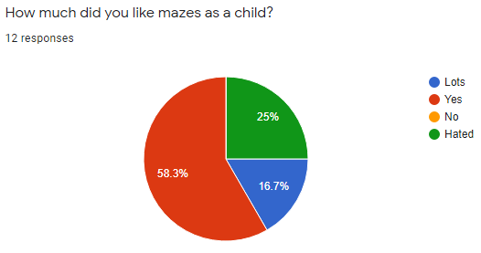Figure 2.

2a. Have you played maze puzzle games on a computer before?

I asked this question to try to gain an understanding if playing maze-based computer game is something people already do.

Figure 3.

2b. If yes, which games do you play?

This follow up question was used to try and gain an understanding of any games on the market I am not currently aware of.

3. Why do you play maze-based puzzle games on a computer?

I used this question to try and understand people’s motivation for playing maze-based puzzle games on a computer and to ensure any design features I include in my product relate to the reasons why people choose to play these games. For example, some respondents replied that they like the problem-solving element of puzzle games which emphasised the need to ensure my game generates random mazes so that the player cannot learn how to beat the computer easily.

Most responses indicated that most adult players use games to occupy themselves when bored. Two people said they play maze-based puzzles to keep their mind active.

4. What makes a puzzle game engaging?

In this question I was hoping to understand what key game features potential players think are important to making a game engaging. Most respondents indicated that having newly generated puzzles each play, having good graphics and racing against the clock contribute to making any games engaging.

5. How many levels would you like to be available in a new game?

For this question results are shown in figure 3. I asked some potential users of my program how many different algorithms they would like to see implemented in the game with the majority (41.7%) voting for 10 with other high numbers such as 6 and 7 in second. This shows me that I will need to focus on implementing a high number of algorithms over other features such as high-quality graphics.

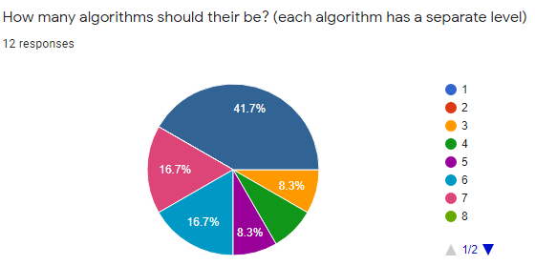Figure 3.

I obtained survey results from 12 people which is sufficient to guide the initial development of my product.

To build upon the results of the survey I also arranged some brief interviews with people from the key stakeholder groups (children, parent or carers, and older adults). Using interviews allowed me speak to children who I had chosen not to include in the survey, due to potential difficulties participating in the survey. The interviews also allowed me to gain a deeper insight into stakeholder perspectives.

Whilst the questions I wanted to ask are relevant to all stakeholders, I decided to categorise my questions by each stakeholder group as shown below:

Questions for children:

1. How often do you play computer games?
2. What are your favourite types of games to play on the computer?
3. Do you find it easy to work computer games?
4. Do you like playing games against the computer and trying to beat it?
5. How do you feel if the computer wins?
6. What makes you get bored of a computer game?

Questions for parents or carers:

1. Do you use any maze games with the children you look after?
2. If so, why do you do this?
3. Do the games you currently use meet your expectations? Please explain your answer.
4. If you could design your own maze game, what features would you include?
5. What would you like the use of a computer-based maze game to achieve for your child?

Questions for older adults:

1. How often do you play computer games?
2. Why do you play computer games?
3. What are your favourite types of games to play on the computer?
4. Do you find it easy to work computer games?
5. What makes you get bored of a computer game?

I interviewed two children aged 3 and 4, who are neighbours. I interviewed three parents, who are neighbours and two older people who are family members.

Results from the interviews with children

1. **How often do you play computer games?**

Respondent a. “When my mum lets me”

Respondent b.“All the time”

1. **What are your favourite types of games to play on the computer?**

Respondent a. “I like to play a game called spaceship maze, where you control the spaceship” - [Spaceship Maze | Free Online Maze for Kids | Toy Theater](https://toytheater.com/maze/)

Respondent b. “I like all games; I like watching my friend play Roblox, but I’m not allowed it”

1. **Do you find it easy to work computer games?**

Respondent a. “Sometimes, I don’t like it when you have to press lots of buttons”

Respondent b. “Yes, I am really good at it”

1. **Do you like playing games against the computer and trying to beat it?**

Respondent a. “Beat the computer?.... laughs… I don’t know’

Respondent b. “Yes, I like those kinds of games, I can beat my friend too’

1. **How do you feel if the computer wins?**

Respondent a. “I don’t know, I think I won’t like that, I want to win!”

Respondent b. “I will beat it! Nothing will beat me!”

1. **What makes you get bored of a computer game?**

Respondent a. “If they don’t work or I can’t do it”

Respondent b. “Nothing! I love computer games”

The responses from the children I interviewed indicated parents have different attitudes to gaming, one child seemed to have as much access to gaming as they liked and another child seemed to have more restrictions on how often they could play. It wasn’t clear if puzzle games were preferred by the children, as both children only said they liked puzzle games when asked about this directly as part of question 2.

From the responses I think making the game simple to operate may be important for children who do not use a computer very often.

Both children, seemed to find the idea of trying to beat the computer appealing, I will therefore try and incorporate this feature into my product. Question four was designed to understand how children might feel if a computer beats them in the game, both of the children interviewed found the idea of this amusing. I would like to include this element into my game to make the game competitive and allow children to practice being perseverant.

Results from the interviews with parents or carers:

1. **Do you use any maze games with the children you look after?**

Respondent c. “I don’t know, they use new games all the time, I prefer it if they are educational but I’m not sure if they do mazes”

Respondent d. “Yes, I think so, sometimes”

Respondent e. “No, it’s usually shooter games”

1. **If so, why do you do this?**

Respondent c. “To help them learn new things”

Respondent d. “To get them doing something constructive, I’ve heard some games are good for memory and problem solving”

Respondent e. N/A

1. **Do the games you currently use meet your expectations? Please explain your answer.** Respondent c. “I don’t really have expectations; my kids choose the games they like”

Respondent d. “I like them to play fantasy games that don’t have too much violence”

Respondent e. “No they are too violent and noisy, I worry the games are not suitable for younger kids”

1. **If you could design your own maze game, what features would you include?**

Respondent c. “make it fun and modern so the kids like it”

Respondent d. “make it creative, non-repetitive and like a quest?”

Respondent e. “maybe bright, colourful and challenging”

1. **What would you like the use of a computer-based maze game to achieve for your child?** Respondent c. “would it make them smarter, like doing puzzles?”

Respondent d. “different style of game might provide variety”

Respondent e. “use a different part of their brains than normal shooter games”

The responses from the three parents/ carers I interviewed indicated that games were only used for education rarely. Most people interviewed did not have any expectations of from the games their children were using. One person whose children used shooting based games did worry they weren’t suitable for children. Although most respondents did want new games to support their children development if possible.

When it came to design features of a new game, several ideas were put forward including, making the game, fun, challenging and ‘like a quest’ but not repetitive. The responses indicated visually the game should be bright and colourful.

Results from the interviews with older adults:

1. **How often do you play computer games?**

Respondent f. “I don’t really play games or use a computer that much apart from sending emails”

Respondent g. “couple time a week max”

1. **Why do you play computer games?**

Respondent f. “I don’t, I don’t really know what games to play”

Respondent g. “just pass the time really, better than TV”

1. **What are your favourite types of games to play on the computer?**

Respondent f. “I don’t do computer games but would like to give it a try”

Respondent g. “driving games or shooter games”

1. **Do you find it easy to work computer games?**

Respondent f. “Never really tried, I’ve seen my grandson play”

Respondent g.” sometimes new ones are a bit tricky”

1. **What makes you get bored of a computer game?**

Respondent f. “My grandson seems to get bored if it’s too easy”

Respondent g. “if the rules are complicated”

The results from the interviews with older adults suggest that whilst some people already play games other do not do this at all. For the person who did play games they did this to alleviate boredom and selected driving or shooter games. This has made me realise that to encourage older people to use a puzzle based maze games, I may need to explain the potential benefits of engaging with this type of product to promote uptake.

Respondent f clearly was interested in trying gaming and would be a prime candidate for using the maze-based game I am potentially interested in creating. The interview with this respondent reminded me of a need to keep the game simple and easy to use, whilst making the game engaging.

As I go forward with my project, Dan, Debbie (Parents interviewed) and John (older adult interviewed) have agreed to provide ongoing feedback on my product at various stages of development to ensure the end product is functional and suitable for the intended stakeholder groups.

The users will require the program to be engaging and fun to play for a time varying from a few minutes to up to an hour. This means that the game must not be excessively repetitive and must have a learning curve that the player will attempt to master, to achieve this I will ensure that every maze will be different from the last and that the player movement is fast paced and difficult to control taking skill to master. My users need this software to provide entertainment and knowledge on pathfinding algorithms. My program is appropriate to meeting their needs as it has familiar controls allowing the game to be easily played but also has multiple examples of path finding algorithms that the player can begin to understand how they work as the software features a visualisation of how the algorithm is sweeping the maze until it meets the end point.

Employers – The software “Lost” will require very little to no external input once operational. I might use amazon web services to host the global high score leader board. Amazon is suitable for this as they provide affordable server hosting for all sorts of applications. If I expanded the development of this game, I would initially employ a small developer team to provide bug fixes. If the game was gaining popularity quickly it may also be beneficial to hire a marketing team to promote the games growth. For a commercial game it is crucial that it does not have any “game breaking” bugs or errors which cause people to lose interest and support quickly.

As my game has the potential to be worked on by a large team later on in its release it is necessary that the program is coded using OOP and it has clear and “to the point” comments that allow multiple developers to update and improve the code simultaneously without creating bugs or unneeded bloat and complexity.

My potential employers will require the game to be well designed and easily modifiable, this will allow them to improve the software and implement features to ensure the game stays popular allowing for a long term position in the company with higher profits and therefore higher wages.

Investors – I expect my game to have very low investment early on as it is an up-and-coming Indy game with no advertising other than free promotions available my posting about it online on websites like Instagram and reddit. The main investment being made here is my own time as the game doesn’t have any operational or maintenance costs once fully released. If the game is doing well in beta testing, I will release the game for £2.99 and attempt to generate revenue from the release.

Whilst I don’t expect to require investors to launch this game, they maybe be required later on if the game grows in popularity. For example, investor funds would be useful to run a marketing strategy, provide funds for ongoing maintenance and further product development. Investors in this product could potentially be education companies (who are after an out of the box approach to teaching how algorithms and computers work). Other investors could be charities looking to engage older people in modern technology or organisations trying to provide a service to alleviate boredom in the elderly. With appropriate testing the game could be used as a ‘brain training’ tool to mitigate against cognitive decline.

My investors will require the software to appeal to a wide demographic with varying levels of computer experience. This means that the software must be simple to operate and understand however it is also crucial to the investors that players are retained so I must ensure this by making the game simple to grasp but difficult to master I plan to achieve this by adding a difficult player control learning curve and I will also make every maze different from each other.

Me – I am a stakeholder as this is my project and the success of the project will grant me an A-level qualification which I will use to support my future career.

If my game is able to generate a profit or large player base, I would like to use this as a lever into the gaming industry where I could be hired by a well-known competitor in the gaming space and kick start my career.

I require the game to showcase the skill of my coding and ability to document the development process in detail whilst also being clear and concise in order to score marks for my A-levels

### What are existing solutions available?

**Review of existing solutions:**

My survey suggests the most popular maze games my stakeholders are aware of are PAC MAN and Labyrinth. These maze games are now reviewed below:

**PAC MAN:** In this game the player controls a yellow sprite as he attempts to eat dots scattered around a maze, while avoiding getting eaten by ghosts. In this game a high score is generated by eating cherries in a sequenced pattern. This game is engaging and was highly successful in the arcade market before modern gaming was developed. The game may support the development of hand eye coordination and assist in the development of some skills associated with playing a computer game. The limitation of this game is the maze does not vary at all from one stage to the next. The development of problem-solving skills is therefore limited. There is no demonstration of the best way to complete the maze and although game speed increases there is no timer to monitor performance.

**Labyrinth:** This game use rotation as a core game mechanic, in this game you are rotating a ball around a maze as it falls, there are hazards that stop the ball or redirect it and the aim of the game is to finish the maze before the clock runs out. The concept of this game is fun but in reality, it is quick and easy to complete with very little challenge. This game does have a multi-player option, but reports claim this is unreliable and frequently crashes.Again, this game maysupport the development of hand eye co-ordination and assist in the development of some skills associated with playing a computer game but the rotation element makes this disorientating for some users. Another limitation of this game is there is no demonstration of the best way to complete the maze.

To explore other maze games available, I reviewed the top maze games according to techigem and GameTop. I used this approach to be time efficient as there a are a lot of maze games available, but they are often hosted and a range of different platforms such as steam and scratch making searching each platform individually would be time consuming. To limit the costs to myself in completing a review of existing solutions I only purchased the top three games listed by Techigem and then focused on reviewing freely available maze games. To be comprehensive I also did a google search for online educational maze games.

To analyse my results and to identify the strengths and weakness of each product I complied a table of results.

**Table 1. Existing maze games**

|  |  |  |
| --- | --- | --- |
| **Best maze games according to Techigem (to purchase)** | **Strengths** | **Weaknesses** |
| **aMazezero** | **Interesting mazes.**  **Random generation of mazes which increase in level of challenge.**  **Simple instructions.** | **Play against self.**  **No solver the puzzle algorithm.**  **No timer.**  **Costs £1.99** |
| **Escape the mazes** | **Random generation of mazes which increase in level of challenge.**  **Simple instructions.** | **Play against self.**  **No solver the puzzle algorithm.**  **No timer.**  **Costs £2.09** |
| **Colourful mazes** | **Good graphics.** | **Limited number of levels**  **Difficult to visualise maze in fully.**  **Play against self.**  **No solver the puzzle algorithm.**  **No timer.**  **Costs £4.79** |
| **Best maze games according to GameTop (freely available)** | **Strengths** | **Weaknesses** |
| **Sleeping Valley** | **Interesting visually.**  **Simple instructions.**  **Several levels.** | **Creepy music.**  **Play against self.**  **Levels do not randomly generate so repetitive.**  **No solver the puzzle algorithm.**  **No timer.** |
| **Proto raider** | **Minimal.** | **Older style arcade game.**  **Poor graphics.**  **Requires reading ability.**  **Spelling errors in game.** |
| **Online educational maze games according to google search (freely available)** | **Strengths** | **Weaknesses** |
| **Happy clicks** | **Simple graphics**  **Easy mazes**  **Easy instructions** | **Only appealing a child.**  **Levels do not randomly generate so repetitive.**  **Limited challenge.**  **Play against self.**  **No solver the puzzle algorithm.**  **No timer.** |
| **Spaceship maze** | **Simple graphics**  **Easy mazes**  **Easy instructions** | **Only appealing a child.**  **Levels do not randomly generate so repetitive.**  **Limited challenge.**  **Play against self.**  **No solver the puzzle algorithm.**  **No timer.** |

Whilst this search of maze games was not exhaustive it has given me a clear indication of maze games currently available. It appears there are either very basic maze games designed for pre school children which they may play a few times before getting bored and then there is a leap to much more sophisticated games which are more interesting and challenging. I believe there is a gap in the market for a maze game which is visually appealing to children and older adults who want access games, which is easy to use but which is challenging and not repetitive. I did not find any games which included a pathfinding algorithm upon completion of the maze which leads me to think this is a key feature I will include in my product. I think this is important if I am intending the game to be challenging and encourage persistence. Sharing how the maze can be solved will encourage learning and demonstrate new ways to do things which will hopefully encourage persistence but limit frustration.

Only one of the games I reviewed included a timer function or produced a score for maze completion, the reward was moving to the next level. To support understanding of the awareness of time and the development of simple numeracy I think including a basic timer and score in my game may be beneficial.

### Summary of stakeholder input and existing solutions review

From reviewing existing computerized maze-based puzzle games and my stakeholder research I believe there is a gap in the market for a maze-based computer game which is appealing to young children, their parents, carers or teachers which aims to not only support the development of cognitive skills, hand eye co-ordination and basic computer skills but also which enables children to practice and acquire problem solving skills included perseverance in a fun and engaging way.

If designed carefully my product can also appeal to older adults who either want to maintain their cognitive function, hand eye co-ordination or learn basic skills in operating a computer and be introduced to gaming.

After taking feedback and reviewing existing products, to ensure my game is original I have decided the following features are important to include in the maze-based game I intend to develop:

1. Challenge against the computer – To support engagement and the development of perseverance.
2. Pathfinder algorithm – To support learning and demonstrate possible solutions.
3. Timer – To add a competitive element and support acquisition of the concept of time.
4. Score recording – To support engagement and competition.
5. Multiple randomly generated mazes – To support engagement and challenge.

### Research of existing solutions which inform product

Existing algorithms which could be used to develop this game include A*[1], Dijkstra's, breadth first, depth first, Floyds, Kruskal's and Prims. Whilst I have limited experience of using these algorithms[2], I will be carrying out lots of research on what the fastest and most efficient algorithms I should include and how to implement them into my program

There are many videos on YouTube on pathfinding algorithms[3]. I will be using previously thought of concepts in my algorithms to ensure they are as effective as possible, whilst also being my own creation. I must make my algorithms more memory and processor efficient than optimal because the program will most likely be ran on low spec school desktop, laptop, or maybe even mobile devices. If a mobile version of the game is released it will have to be optimized to function on reduced instruction set computing techniques and implement the devices touch screen capability instead of keyboard and mouse, this is the case because mobile devices usually used reduced instruction set computer processors which are more energy efficient but far less powerful than conventional complex instruction set computer processors usually found in desktops, this difference in power will require different levels heuristics to reduce processing requirements.

The A* algorithm is well known for being the best pathfinding algorithm available with its decision making based on how “expensive” it is to move to the next junction also known as the “h” value and how close that junction is to the desired destination. This makes it incredibly fast compared to other algorithms however heuristics must be implemented to reduces the processing power required to calculate the estimate the h value as the exact value is very processor intensive making the program too complex to run.[1]

The Dijkstra algorithm is another fairly efficient algorithm which focuses on taking the shortest possible route between any junction which leads to the destination.

Breadth first and depth first algorithms are fairly simple as all they intend to achieve is to spread the search out from the starting node as far as possible and then slowly work forward or search as deep into the maze as possible and then expand width from there respectively. Although these algorithms are inefficient, they are not processor intensive and work acceptably in small areas.

Many programs use path finding algorithms, for example google maps, with 154 million monthly users, features a combination of Dijkstra’s and A* algorithms to find the most efficient route to get you from A to B. Because of this I plan to implement Dijkstra’s and A* first in my program as they are the most complex with real world benefits. Using these two algorithms will also benefit the project as they follow similar design to each other allowing for easier development. A* uses an additional heuristic value to make path finding more efficient however the rest of the code is very similar to Dijkstra’s algorithm. Using OOP in the development of my project should make implementation far easier as they can both access the same variable names and methods.

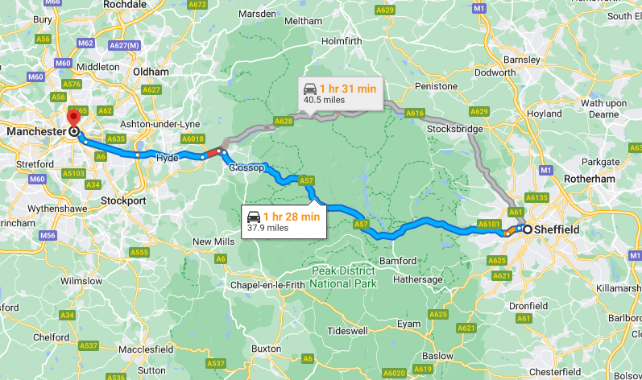

Above is a screen shot of google maps which has used pathfinding algorithms to find the fastest route between Sheffield and Manchester, it uses a combination of A* and Dijkstra’s, this allows for high efficiency and high-performance route finding google is able to find a long route quickly due to its use of datacentres around the world which carry out all the processing on behalf of the user on the other end, as my game features far less demanding path finding capabilities and does not feature internet access in its current state.

Due to the small size of my game, I will not be able to use cloud-based servers to host the path finding algorithms, this allows for larger mazes and more low-end hardware to access the game without losing all of my profit margin, however if the game becomes extremely popular there is potential for this feature to be implemented.

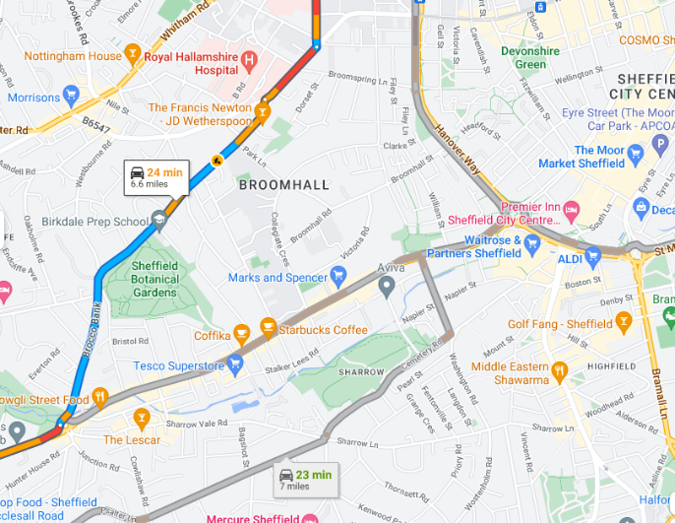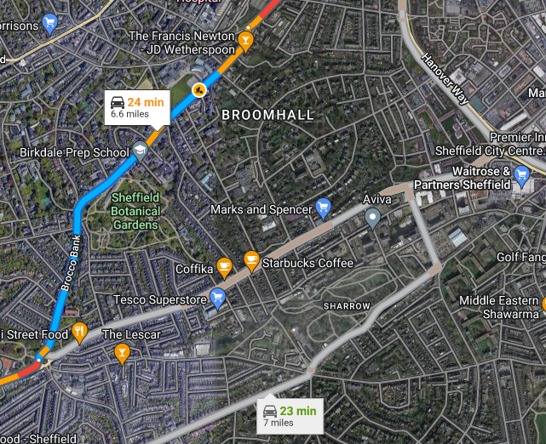

In the above screenshot, Google has opted to provide two different levels of abstraction. This provides the user with a highly abstracted map on the left, which removes almost all unnecessary detail not required for travel whereas the map on the right provides high detail satellite imaging allowing for the user to get their bearings more accurately. However, the added complexity makes it harder to use in a vehicle where you don’t want to be distracted. My game will feature a similar option to the two levels of abstraction offered by google. In the first lower level of abstraction, called the “debugging mode” the path will be marked with different colour nodes and “corner” vertices compared to the rest of the path.

In the development of the game, I will also create a mode with excess detail which displayed the distance to each neighbouring node on each connected corner node, I will probably remove this code from the program as it made the program unnecessarily bloated and provides no purpose for the end user however it significantly helped me in other aspects of education and hopefully will help me to develop my program when trying to implement my own path finding algorithms.

I assume google has their own “developer only” mode for google maps which helps visualise the massive amount of data they are dealing with. It just goes to show how effective graphics are at helping humans make sense of data, such as that in this this graph. It should really help me get the code moving again once I hit problems.

Another good example of software that features complex pathfinding algorithms is the Call of Duty: Zombies series. In this game a player is loaded onto a map and is then chased by numerous zombies loading in from all sides of the map. The pathfinding algorithm is complex as the end point (player) is always moving and thus the route must constantly change, the start point (zombies) also get loaded in from varying positions and must not collide with each other so one “perfect” route cannot be used otherwise the zombies would appear in a line and not a group. Below is an example of what a player being followed by a small hoard of zombies looks like. In this example you can see the zombies are all coming from the same direction however that is just because they were loaded in previously and have been following the player for a while.

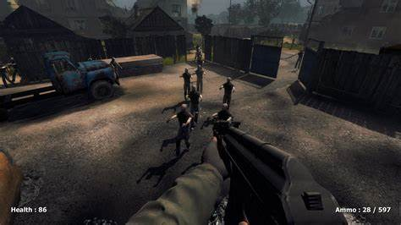

My maze game will not encounter a lot of the same problems that this style of game creates however the idea of a pathfinding algorithm that is fully functional in a wide variety of landscapes such as the randomly generated mazes that will feature in my game.

Above is diagram of the zombie Map with red squares being zombies and green being the player. This is to help showcase how the pathfinding algorithms in this game are used to navigate the large map filled with objects.

Specifically, games like this use Dijkstra’s algorithm to path find the zombies to the player however they use a very interesting implementation of Dijkstra’s to achieve memory efficient and accurate pathfinding for several zombies[11]. Dijkstra’s algorithm is implemented in reverse with the player calculating all the shortest paths to itself (end à start) this allows for the zombies to never get lost no matter where in the map they are. I am keeping note of this implementation strategy for my own game if it becomes apparent that the conventional “start à end” implementation is creating errors or inefficiency. It may also be needed to allow the path to be connected to the player and not just the start point the player is loaded onto.

### What are the limitations of existing solutions?

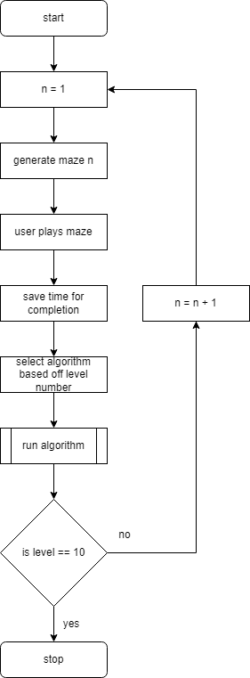Current solutions do not allow a user to play the maze before watching an algorithm attempt the maze. This allows for a more of a game like style with user interaction as opposed to just watching, not all current solutions give a real time visualisation on how the algorithm is figuring out the path. Current solutions also do not provide any suitable user interface such as a menu or simple start button, this is because the solutions were designed for demonstration only making them difficult for people to interact with.

**Figure 1**

**Figure 1** shows a brief summary of how the program is supposed to operate, many features have been abstracted from this diagram to make it more understandable such as the high score leader board, the scaling of maze size depending on level number and more.

### Is your proposed solution going to address those limitations?

YES! My software will be implementing a way for the user to play the maze and then compare the route and time with that of an algorithm, my game will also visualise the algorithm completing the maze by showing in real time the steps it is taking. My program will be more complete and user friendly than other versions of pathfinding games with features such as a main menu, level selector and high score this will enable the game to have competitive scores for levels and bring new dimensions to the game not seen in other programs. I plan to have simplicity and useability as priorities so old and young users alike can learn easily how complex algorithms work without having to see the sometimes-overwhelming backend of the program.

### Essential Features

My game will be dependant on certain complex features working without bugs or imperfections, the items listed below will outline which features are absolutely necessary for the game to function as intended

1. Maze generation – mazes must be able to be generated randomly and consistently on low end hardware without causing extreme hardware usage and/or crashes. Mazes must always be produced “perfectly” with only one route to the exit.
2. Path finding algorithms – must be able to function correctly in any maze that is generated, must be able to display the path finding “search” visually so that the user can see how each algorithm differs from each other. Algorithms Must be implemented efficiently so low end hardware can be used without causing extreme hardware usage and/or crashes on larger mazes.
3. Time storage – each time a maze is completed a recording will be logged and stored in a database file, this time log must be extremely accurate to encourage competitive play. time logs must also be stored in a robust un editable file to prevent tampering and to ensure times are not lost unexpectedly.
4. Controls – my games inputs must be precise and have low input latency to allow for high competitiveness between the player base who are participating on websites such as speedrun.com
5. login system – login system must be secure and preferably use hashing, system must allow for users to create a new account and have it be saved in a database that will not forget the information when shutdown
6. login system must relate a user’s high score to their userID, relations must also make efficient use of storage.
7. Login system must not be penetrable via hackers

### The limitations of my own program

My program will be limited to only using very simple graphics which some users may be unsatisfied with, as modern AAA games feature such advanced graphics. However, this limitation is present because it is takes too long for a single developer to code advanced graphics for my deadline. In addition, I need my game to be able to run on all specifications of hardware and as advanced graphics do not work on low end hardware this would be a barrier to using higher end graphics.

My game will also not feature a machine learning algorithm as I do not know how to implement AI (Artificial Intelligence) and I feel it would take too long with my already tight schedule of having to program multiple advanced algorithms into the game. However, there is potential to extend the project in this manner in the future should I choose to learn about AI.

My program will also be limited in its ability to scale to different monitor sizes, I am worried that the game may appear too small on a 4k monitor due to the window being a fixed resolution. I plan to roll out an update if this becomes a problem for users, however I am not addressing the issue yet as I need to complete more serious components of my program first. Also, the demographic for this game means it is usually going to be played on low-end, low-resolution hardware so resolution should not be an issue.

### Software Requirements

My program will require a computer running windows 10, with executable files enabled, I plan to make my final release of the game a self-contained executable file with no other dependencies or software requirements.

To download the game the user must have a web browser installed and an access to the internet, however once installed the game does not require internet access

### Hardware Requirements

Appropriate peripherals include a monitor mouse and keyboard. I will attempt to keep the hardware requirements of the PC as low as possible to enable the game to be ran on school and other low-end hardware although a multi core processor will most likely be required. No specialist hardware such as a joystick or webcam will be required. I estimate my program will require a minimum of 2GHz processor 2GB of RAM and windows 10, and a recommended 3GHz processor with 4GB of RAM. A multicore processor is recommended for this program as complex path finding algorithms can be very demanding on the computer.

Computer must have sufficient storage space to install both the game and hold any other data such as that contained within the database created for storing high scores along with their associated user

### The objectives

The objective is to complete mazes which increase in size as the game progresses. Once a level is completed the game will run a search algorithm with a complexity correlating to the level the player is on. The routes of both the player and algorithm will then be compared side by side to show how the algorithm found the path in comparison to the player. A time will be recorded for both the player and the algorithm allowing for competitive best time scores.

The user should be able to watch the algorithms calculate their route in real time e.g., see the trail on the maze as it moves rapidly.

The main problems I envisage I will encounter are coding the path finding algorithms and coding the automatic random generation program. However, there are plenty of online resources to help me understand these concepts.

I have decided to name the game “Lost” this is because in this game you will be put in the shoes of character who must escape the maze, he/she has been lost within. Hopefully the game will provide enough engagement for the user not even notice the problem solving and other cognitive skills they are learning. I will engage the user using: background music (this feature was heavily requested with 84.6% of votes in support on the form I made), an easy to interact with menu and high score system.

After completing the above objectives I was able to implement a login screen. This login screen had many objectives, the first and foremost being to connect a users high score to a given username allowing for one computer to host multiple accounts which is necessary in the intended situation of educating many different people on the same machine which such as in a care home or children’s hospital.

A potential secondary feature of the login system will also attach each username and password to a User ID which could be shared online to allow players to compare high scores via a third-party in a later version of the game.

The login system will also require passwords to be hashed before being stored or checked for logins for increased security against hacks or data breaches if the game ever gets made online. The login system will also be protected against brute force attacks by timing out after 5 incorrect logins and protected against injection attacks by only allowing alphanumeric inputs by validating the result after it is entered.

## Computational methods:

In my project I plan to be use a range of computational constructs to increase the efficiency of my program and showcase my ability to code with advanced techniques.

Essential features of this game include and ability for the program to read and write to an external database file in order to store and present a high score value that does not get reset when the program is closed. Pathfinding algorithms must not lag or produce incorrect/suboptimal path solutions when ran, this will be achieved by following previously developed designs and implementing them myself, algorithms like A* and Dijkstra’s will only provide the shortest path. Another safety net for this is that my maze generation algorithm will produce a “perfect” maze with only one route between the start and end points. It is also crucial the algorithms and player sprite work within the bounds of the maze and do not glitch through walls at any point, however I aim to program my code in a way to make sure this cannot happen as the sections of maze you can move within will be stored separately to walls.

Prompt Maze generation is also vital to the functioning of the game and must create an intricate and “perfect” maze rapidly, it is crucial that this maze generation algorithm creates attributes and methods such as “neighbouring points” and other key values as it generates so that the path finding algorithms have all the information needed to function correctly. I will ensure that the maze is generated rapidly by ensuring I use an efficient algorithm. I plan draw the maze by placing a vertex on a random edge of a previous vertex as long as it only has one connection. Once this process has been completed and the previous vertex eventually gets stuck and does not have any space to place another vertex, I will use back tracking to go back through the path I made until a vertex with an available space is found and then the process will repeat from there until eventually the whole maze is filled.

Decomposition– Decomposition is the breaking down of a complex problem into small more solvable problems. In my program I will be using the technique in the path finding algorithms and graphical user interface as both of which I have never attempted to implement into a python program of mine before. For the pathfinding algorithms I will be separating the complex idea into parts such as (movement, type of algorithm and how the algorithm is able to see where it is) this should make the process similar and more manageable. With the graphical user interface (GUI) I will separate the program into (timer, map generation, algorithm real time visualisation, “trail” system and player control) most of the sections have plenty of online research and are hopefully simpler to implement than the path finding algorithms.

Abstraction– Abstraction is the process of removing unnecessary information from a question or task to increase efficiency or decrease complexity. In my program I will be using abstraction to remove unnecessary data from the program such as highly detailed textures and grid coordinates as the program will already be processor intensive as pathfinding algorithms are difficult to run, the exclusion of grid coordinates in the GUI is simply to make the maze more aesthetic and easier to follow as I feel having words in each square would look crowded. Abstraction will also be used in my planning as I will be excluding information on the user’s player until the algorithms are complete to increase focus.

Algorithmic thinking – I will focus on using an algorithm-based approach for my project this will make it as efficient as possible. This is more efficient than conventional methods because with only simple trial and error programs it could take hours to solve a complex maze, algorithms choose which paths to check with maths not just guess work resulting in an average much faster solve time than conventional. This algorithmic approach automates the problem-solving process by making a list of logical steps which will give perfect outputs if the correct inputs are given. Algorithmic thinking is also what lends my project to being delt with computationally as computers are far better at understanding pre-set instructions such as path finding algorithms which will feature in my program, for these algorithms to be effective they must be ran quickly without errors. Modern day computers are able to do both very reliably. Hence, why I am making the project as a computer game not a board game.

Pattern recognition – Pattern recognition is the process of data analysis that uses machine learning algorithms to automatically find patterns in data. My program will use very little pattern recognition as the algorithms involved do not utilize it. However, to showcase pattern recognition I may develop a machine learning algorithm and add it to my game. This will depend on how long the other algorithms take to code. Although the program will not use pattern recognition that doesn’t mean the user can’t either, the user will be using pattern recognition to identify the fastest route possible, humans are naturally very capable at solving small computational problems such as mazes with our subconscious doing most of the work automatically.

Encapsulation – Encapsulation is a feature of object-oriented programming which prevents certain variables form being affected by the other code allowing for key variables such as bank balances to not be edited with glitches. In my program I will be encapsulating information about the speed at which the player and algorithm can move and the data for the time so that users cannot easily modify variables to get high scores or move faster than intended. Because my program does not have any data which is personal this is less important to implement.

Inheritance – Inheritance in computer science is the idea that pre-configured characteristics can be made generic enough to be passed down from a general (super/parent) class to multiple more specific sub (child) classes so the programmer can avoid programming the same piece of code repeatedly. Code using inheritance is often more efficient for the programmer as it requires less time to implement in large projects than conventional programming. Inheritance will also be used in the user interface as pre-set colours and fonts will be easily passed down benefitting the user as it all works similarly in my program, I will be using inheritance to pass down the characteristics of the “snakes” both the algorithms and user will be controlling, characteristics will include “speed”, “shape” and a variable for “colour” since both the algorithm and user will be a child of the class snake this is an example of polymorphism.

Heuristics – Heuristics is the idea that a computer can be more efficient by decreasing accuracy in exchange for speed, in my program I will be using this optimization. My program will rely heavily on heuristics as creating fast approximate values for the algorithms is key instead of creating slow exact values for variables such as “h” which is known in path finding algorithms as the movement cost to move from a given square on the grid to the destination. Calculating close estimates of this value dramatically increases the time taken for the algorithm to complete a maze as finding the exact value can take so long. In particular I will be using a technique called “Manhattan distance” which is the process of creating an estimate of h by calculating the sum of values of differences in the goal’s x and y coordinates and the current cell’s x and y coordinates respectively this is done easily with the equation.[1]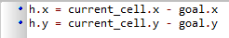

Data mining – Data mining is the process of collecting information about patterns and relationships in large volumes of data, my program will not feature this computational construct as I do not believe any data can be taken from this program to improve itself or make profit, If I was to store data about the user’s computer hardware for performance diagnostics, I worry that I would be intruding on the users privacy which is especially important if the software is to be used by children.

Hashing – my login system will feature hashing as all password inputs will be hashed before they get stored or used within the program, this will ensure that user data cannot be stolen or altered. My program will also make use of a composite key system that will involve combing the username and hashed password together. The password encryption I plan to use is called SHA-256 it is extremely overkill however its also relatively easy to implement and shouldn’t cause any problems so it seems like a fine choice.

## Success criteria

I have made this Gantt chart to keep track of my project deadlines and allow me to calculate my current progress quickly and easily, the red line tracks the current date.

|  |  |
| --- | --- |
| Success Criteria: | How to evidence |
| A successful program should allow the user to play the game on low end hardware without noticeable performance issues | Run the game and test all features on school hardware |
| the user should be able to complete randomly generated levels and set high scores to an online leader board | Game will upload a player’s high score and connect it to a player’s username |
| the game should feature multiple advanced and simple path finding algorithms | Game will have more than one option for a complex path finding algorithm |
| the user should be able to watch the algorithms calculate their route in real time e.g., see the trail on the maze as it moves rapidly. | Path finding algorithms will display their search visually when moving through the maze when triggered |
| Software can access the internet to provide automatic updates | Launch a bug fix and see if program updates |
| Successfully implement **A\***, **Dijkstra’s**, **Depth first** algorithms | Algorithms are able to search within the bounds of the maze without crashes or bugs |
| Game should be able to be played by one player | Game has single player option |
| Levels should change after every completion | Complete a game and see if the next maze is a different layout |
| Game should have a high contrast allowing for visually impaired users to access | Game features highly contrasting colours throughout |
| **ADDITION AFTER COMPLETING OTHER SECTIONS:** |  |
| Login system hashes passwords before storing | Check code only stores hashed passwords |
| Login system will relate a username to a high score | Login an see if username and high score are displayed on menu |
| Login system should prevent massive data types | Try to enter a 30-character password and username and see if its invalid |
| Login system should prevent SQL injections | Try to enter a basic sql injection print statement and see if it works |
| login system will prevent brute force attacks | Enter 5 incorrect passwords and see if system exits |

# Design:

## Objectives:

The goal of my program is to provide a simple way for children to understand the “behind the scenes” of how everyday computer software for mapping/route finding works, by showing off the methods the accompanying path finding algorithms use. I aim to achieve this by abstracting the information of a map into a maze and make it entertaining by using engaging graphics and interactive levels. The secondary goal of my project is to provide infrastructure for other programmers to test out and develop new path finding algorithms by providing an easy to understand and well dictated code. Algorithms will be able to be implemented directly with python code without the need for “cracking” the program. As I will include both a pre-configured .exe file and all the python open source code in the file.

## Decomposition:

Inputs –

* Enable keyboard + mouse peripheral systems to operate effectively (with lag <30ms and with accuracy) within the program

Processes –

* Program is capable of quickly (<10 seconds) generating a random, “perfect” (with only one exit), solvable maze
* Program is capable of running a search algorithm to solve the maze
* Program is capable of allowing the user to control an in-game sprite
* Program is capable of recording and monitoring time spent in levels
* program generates a user ID for every username + password combination
* program stores a players high score with their user ID

Outputs –

* Enable program to display visual results of the algorithm in real time
* Will output messages to the user when they are signing up/ logging in, in response to the system errors.

In this section I will be using decomposition to break my program down into a list of achievable sections which will come together to complete the program. I am using decomposition to make the development process easier and more incremental; this method of decomposition is commonly known as divide and conquer. This process will allow me to manage any problems as I develop the program and aims to prevent any problems being carried into the next phase.

**Maze generation** – I will create an algorithm to generate a completely random maze, the maze will be “perfect” (a maze with only one route from start to finish) as I want to demonstrate that certain algorithms will be able to find the same route quicker and more efficiently than others, the maze generator code should also be able to have variable parameters for dimensions.

The maze must be generated in a format the algorithm can interact with not just a picture of a random maze, an example of a similar project to mine is figure[4] .

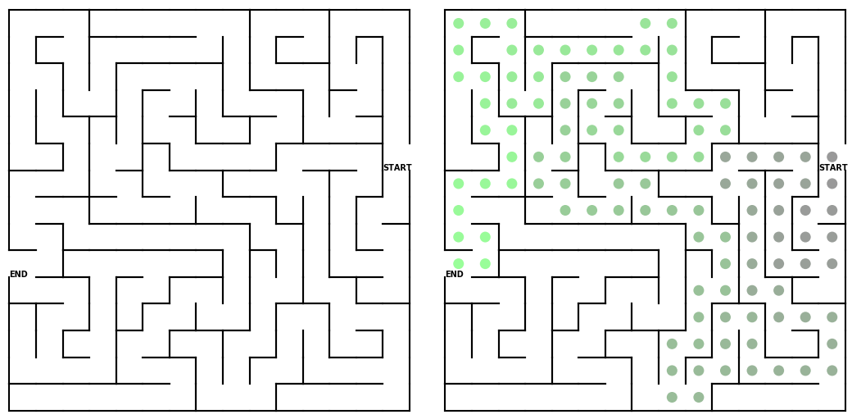

Generating a maze using my own subroutine will ensure it can be edited and adjusted as required.

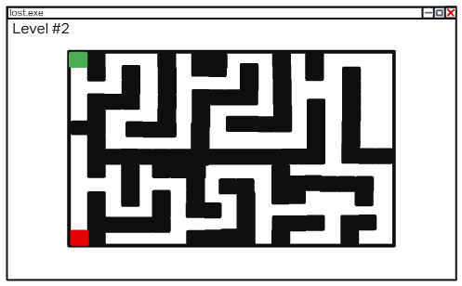My project will be similar to the above design as the algorithm to create the maze is random and perfect. However, my design will not be the same as the walls in this maze are thin whereas my walls will be the same dimensions as the moveable spaces like this:

This design should make graphing the map easier and make movement for the sprites for both player and algorithm more simple to implament.

**Algorithms** – I will have to code multiple algorithms from scratch in my program each one will be time consuming to create so I must remember to leave plenty of time to complete them, I plan to include the following A*, Dijkstra’s, breadth first, depth first, as these algorithms are more well-known and well researched. If I implement these quickly, I may also include, bidirectional, Floyds, Kruskal’s, Prims, however these algorithms will provide no additional functionality to the program and would therefore only be used to expand my personal development in this area.

All of the algorithms should function with a “one move at a time” functionality so they can be implemented as a live visualisation in the game, which will enable me to meet my output objectives.

**Implementation** – creating functioning algorithms will not mean they are complete as they must be able to interact with the maze generated and show how they are moving in the maze in real time. Also, the user must be able to interact with the maze and ensure bugs such as wall clipping, and spamming do not create any errors as it will make the program unusable.

**Finalisation** – I would like the final version of the project to be launched via an .exe file, I have found an online .py to .exe converter[5] this will make the program be able to be launched on any machine it is downloaded on easily with minimal setup and installation knowledge, this will be important as the target demographic for the game is old and young people.

**Login system** – my login system will feature a SHA-256 encrypted password function for maximum protection against decryption attacks. The username field will not allow duplicates to ensure no collisions are made in the database. The user ID will be made of a composite key between the hashed password and username value this allows each record to be easily identified and accessed within different areas of the program without variable names getting confusing. Each User ID is there for connect to its own record with its own username and password, each record will also contain a users high score time, this will be checked after maze completion but only updated if a lower time is achieved. All of this data will be stored in the .npy I made before adding a login system previously called maze_times.

## Modular based design / structure:

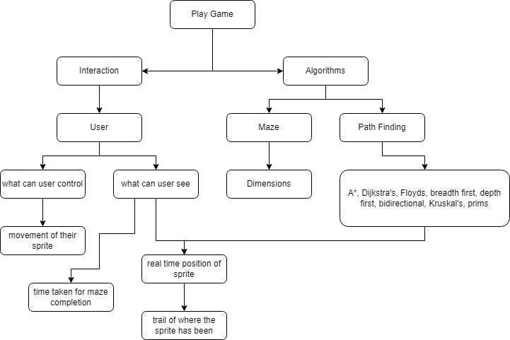I aim to program the code in a modular way enabling for the reusability of code and the simple understanding of the program for further development. The program will contain many subroutines to keep the program more organised. I have created a decomposition diagram to help demonstrate how different sections of code and data will be organised and how they are connected within the program.

Movement – movement of sprite should be simple to implement with basic arrow key controls, movement should be responsive and simple will require the input of a keyboard for the arrow keys. I have decomposed this problem to make implementing the features I need faster and less complex.

Time – A clock will require a library import; however, the implementation should be simple, it will measure the time taken to complete the maze in minutes and seconds, not hours as no maze in the game should take more than 59 minutes to complete and not counting hours value should save memory, this has been decomposed to ensure that I do not accidently make the program less efficient buy adding unneeded variables/features.

Trail – the sprite I will be using for the user, this will leave a coloured in trail to mark the route it has taken to make analysis of your own gameplay more enjoyable.

Dimensions – dimensions of the maze will have to be scalable to meet the requirements of different levels throughout the game this will mean the maze must be generated not manually designed, this has been decomposed to help me implement improved compatibility into my maze generation algorithm

Testing – I will be using an iterative development process for rapid development I aim to make multiple prototypes until I reach the final release, my method of development has been decomposed to give myself clear instructions on how development is expected to take place, so I know every stage is going smoothly.

Graphics – program as a whole will require a colour monitor to display the information required to play the game and adjust settings the graphics will be basic but still require modern 60Hz+ monitors in order to show the rapidly changing route of algorithms without stuttering.

Login system – the login system will use a database with 4 fields, the first being a primary key called user_ID which will be randomly generated using a Universally Unique Identifier (uuid) module, and has an extremely low chance of collision due to the randomness being based on “time” itself and the “space” the user_ID is generated in. the next field is username, this will be entered by the user when signing up and will not be altered allowing the menu to display the username of the logged in account. The users password will also be stored however it will go through a SHA-256 hashing algorithm before being encoded using the utf-8 standard and then converted to hexadecimal for more efficient storage usage. The last field is known as high score, this field will contain a given userIDs lowest maze completion time and will update after every maze completion with a lower time.

### Page layout:

The game will open with a basic start menu, once the play button is clicked the player will load into a freshly generated maze where they will be given control of their sprite.

I also plan to implement some basic accessibility features such as colour-blind correction and high contrast settings

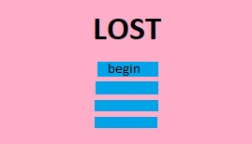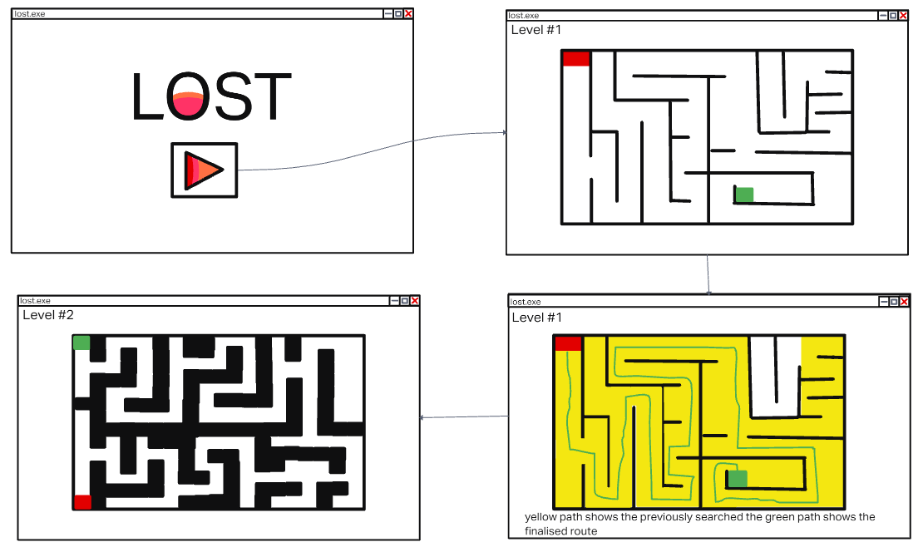

The diagram above aims to demonstrate how the user will be directed through the different stages off the game/program and what each stage contains in terms of user experience and options, hopefully this diagram helps me to decompose my problem when it comes to creating each part step by step within python.

1. 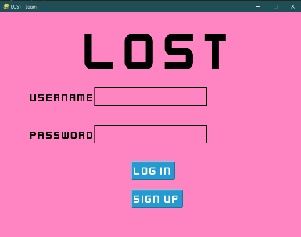the login screen will feature a simple and clear interface allowing for a user to either signup or login to existing account. The input boxes will fill with characters as inputs are given, however the inputs will then be validated by ensuring the input is alphanumeric.



2The start menu will feature a simple title screen and a stack of vertically aligned buttons these buttons will contain a “begin” button to start the program, a “debugging” button to toggle a mode with search algorithms built into the maze, a “clear times” button to reset your high score. I may also implement a “tutorial” or “high performance” button.

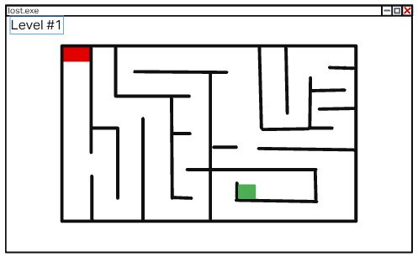3) The begin button will lead straight to this page where the user will be prompted to begin moving through the maze, their sprite will leave a “trail” behind it indicating where they have travelled within the maze. Whilst the user is completing the maze a stopwatch style timer will be counting how long the game has been going on for until the user reaches the end. Once the end is reached the user will go onto the next page.

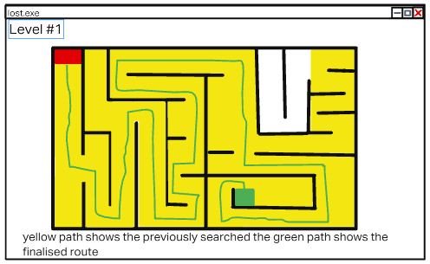4)This page will first show the name of the algorithm which is going to be ran, then the algorithm will begin running and the algorithms sprite will begin moving in real time and everywhere the sprite has explored will be highlighted in yellow, once the sprite eventually reaches the end node a green line will connect the start point to the end point through the shortest most efficient path which can be calculated using the currently uncovered nodes.

5)Once the previous level is completed the next level will be loaded, this next level will be slightly larger than the previous making it more complex so harder for an algorithm to figure out. Again, the user will be given control first and a stopwatch will record their time.

## Object orientated design:

My program will feature object orientated traits such as:

Polymorphism – will enable functions such as “StartAlgorithm()” to begin different running algorithms at different stages within the program such as on level 1 “StartAlgorithm()” will run a breadth first algorithm whereas on level 6 “StartAlgorithm()” will run A* algorithm.

Inheritance – my program will use inheritance to pass on data to entities who must operate within the bounds of the maze e.g., player sprite and algorithm sprite will inherit data telling them how to interact with the “walls” within the maze and the speed they should move at.

It is advantageous to use inheritance as it ensures standardisation across multiple functions which will make the combination of the maze, algorithms, and player easier to implement. Reusability due to inheritance is also reliable as its parent class is already tested and known to be more robust than a fresh module.

Data abstraction – I will be including all of the mathematically important data required for the algorithms and all the data required for the user to play without bugs however excess data such as the texture for the maze will be changed to a simple block colour. Abstraction is key to this project as the vast amount of information that is needed for the algorithms to understand how to reach the end of the maze will make the development very complex but by ensuring only the data in use is included in the software and that said data is well organised and it is made clear how and where it should be used.

## Key variables and data structures:

Please note that some of my data will not require validation as no unknown user inputs are available, all inputs are either buttons or keyboard inputs with pre-set actions for movement. However, the accounts generation and login details will need validation.

|  |  |
| --- | --- |
| Variable names / data structures | Description |
| “h” value | the estimated value for the movement cost from a square on the maze to the destination it will be, it is calculated by with  h = (current_cell.x – goal.x) + (current_cell.y – goal.y) |
| “g” value | The lowest cost that has been calculated so far to move from the start node to the current node on the board |
| “f” value | f = g + h is used frequently in the A* algorithm to calculate the most efficient rout to the end node, this is the value which makes the A* algorithm have “brains” in comparison to other algorithms |
| Completion time | the amount of time it has taken the user to complete the level they are playing; this will be important for the user to manage their self-improvement |
| Programming language | I will primarily be using python in the PyCharm IDE as it is what I am most familiar with, and I should be able to find the most information on different techniques online. Python should make it easier for me to learn more advanced techniques as I already have a good understanding of how code will be laid out and how data structures are used. |
| Potential neighbours | An array which will change based on the currently selected node, it will contain all the surrounding nodes |
| Unvisited neighbours | A short-listed version of the “potential neighbours” array it will remove all values which have been previously visited by the algorithm by checking for a wall |
| Visited | An array which contains every visited coordinate |
| Midpoint | MidX + MidY which will be calculated from |
| Player speed | This will be a variable that I plan to be changeable by the user in the settings menu it will have a slider that dictates the number of pixels per tick the player moves |
| Width, Height | This value will dictate the resolution of the window generated in pixels |
| Player points  (player_top_left) | There will be multiple versions of this variable for each corner of the player character, they will each contain the exact coordinates of the corner. In this case the top left will be written as player_top_left = (self.x, self.y) however as this corner is for an upward collision we also need to add (-self.speed) from self.y so there will be no jittering or clipping. Final version will look like this:  Player_top_left = (self.x, self.y – self.speed) |
| User_ID | This will be a randomly generated Universally Unique Identifier created with the uuid python module that makes each stored record unique allowing for other sections of the program to be able to access all the user data they require with just the user ID |
| Username | This will be entered by the player at the signup stage and will remain in storage without being modified to allow username access to all areas of the program |
| Hashed_password | The password will be taken at the signup stage and then instantly hashed to ensure security, and is then stored in the data base to allow for a user to sign in. |
| High_score | After a successful maze completion, the new time recording and the currently stored high score will be compared and if the new score is lower the stored score will be overwritten, this ensures that a given user always stores the best high score |

## Algorithms:

### Maze

The First algorithm I will have to develop is my maze generation algorithm, for this I will be using a randomised depth first generation algorithm. It works by starting at a given position on the maze and moving one “square” at a time on one of its random available edges (1-4) eventually this route will get completely blocked and there will be nowhere else for the “tip” of the route to go, at this point the algorithm will backtrack to the nearest available point and carry on from there. This process is repeated until every square in the maze is filled and you are left with a maze like the image below Which is exactly what I am looking for with my program, note that every maze will be “perfect” with only one route to the end, and it will also be completely random with many trillions 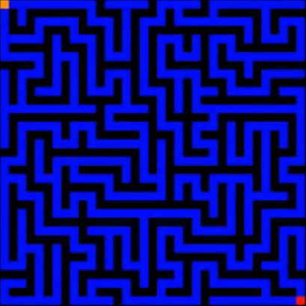of variations:

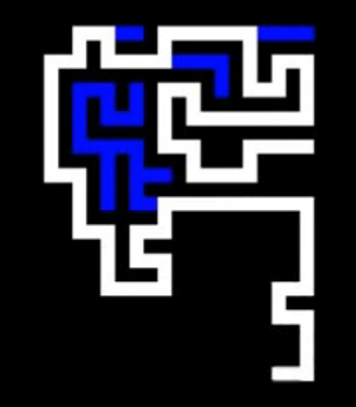   
below is a snip of what the maze trail looks like with blue sections being the paths which have been backtracked through In order to continue the route.

This method of implementing a maze generation algorithm is advantageous as it is fast to compute and requires less variables than other options, the more practical way of implementing this algorithm for large projects such as mine with many data points is to uses iterative functions over recursive functions as with recursion may exceed the maximum recursion stack depth in many environments whereas iteration will avoid this with any reasonable sized maze set.

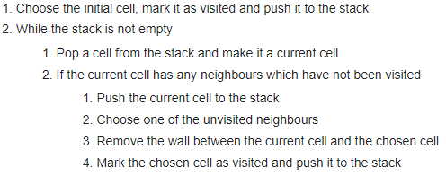

Above is the Wikipedia explanation[10] of the design I will be implementing, by using a stack we are able to check if any neighbours are available and if so we can move to a random node of the available, if not we begin backtracking until a neighbour is found and begin the process again.

The randomised depth first search algorithm has a tendency to create long corridors of path with many shorter side route making for a maze that is slightly easier to solve than others but in my opinion also leans more towards better gameplay as the character is able to move faster on the straights for short periods making the game more engaging.

My software aims to contain a range of different pathfinding algorithms. To bring diversity and make the game feel less repetitive more advanced algorithms will be implemented in higher levels in the game making the user want to continue playing to see the best algorithms available.

### A*

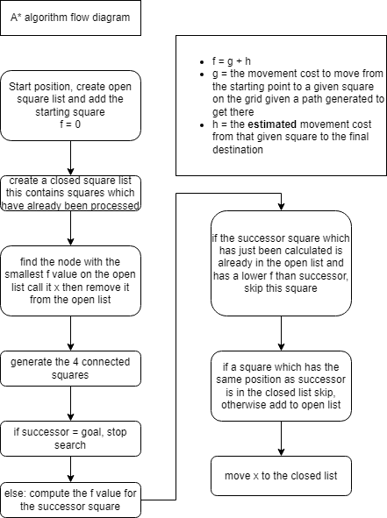 This flow diagram shows how I will be implementing the A* algorithm into my program. This diagram aims to assist me when coding this algorithm as well as providing a clear set of instructions on how to implement it, this will help me achieve a greater understanding as the problem is decomposed and thus easier to program. It is important to note that the open list contains the coordinates and f costs of unchosen but generated nodes, the closed list does not contain the obstacle’s locations but the coordinates of nodes which have already been visited to prevent the repeating of searching a node.

One great characteristic of the A* algorithm is that it must and always will find the most optimal route from start to finish as the shortest route is always chosen first.

### Dijkstra’s

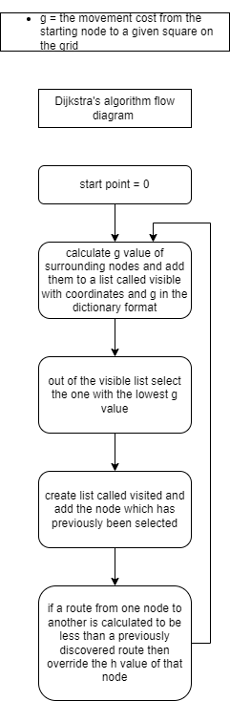Dijkstra’s algorithm is an example of a shortest path first algorithm. It is very efficient in small mazes as its calculation cost is very cheap as no heuristic data needs to be generated. However, when the maze gets larger it becomes exponentially more inefficient than other algorithms as significantly more data points are needed to be processed, despite them being cheaper as shown here[7].I plan to use this algorithm early on in my game as that is when it will be most effective. However, it may be interesting to show how ineffective it is in a large maze. This algorithm should be far easier to code than the A* algorithm as it requires less variables and far less calculations to be made.

It is important to note that this algorithm calculates the optimal path between almost all nodes in a graph not just the destination value as the algorithm is considered a “blind” search, this results in a very inefficient use of memory and processor time.  
  
Breadth first

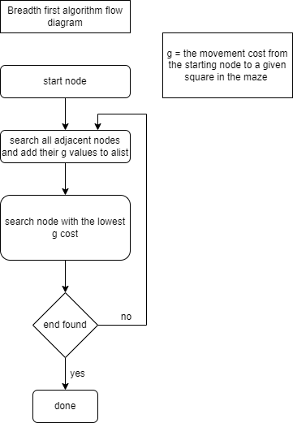 With the breadth first search algorithm all of the expansions happen in a pattern of uncovering nodes nearest to the start point as possible. This lends itself to finding the shortest route between start and finish in a highly wall dense maze, breadth first search becomes incredibly inefficient when there are large portions of “open” space to travel through which most other algorithms find very simple. However, if given the optimal conditions, breadth first becomes a very simple to implement and non-hardware demanding algorithm due to its lack of the need for heuristic calculations.

Note: this is not implemented within the release state of the game however I have left the design here in case of a game update if requested by one of my stakeholders.

### Text Description automatically generatedDepth first

This algorithm is optimized for mazes with un-dense walls, quite the opposite to breadth first, this algorithm shines when put in a large maze with very few walls. It is designed to have a minimum spanning tree making it very efficient at travelling long distances without wasting a large amount of processing power. The depth first algorithm also has some similarities to breadth first search as it only stores information on nodes in the current path. Depth first can lead to the finding of an inefficient/further/too deep route from start to finish if the maze is not perfect however in this case that should not be a problem as my maze generation algorithm will be “Perfect”.

Note: this is not implemented within the release state of the game however I have left the design here in case of a game update if requested by one of my stakeholders.

### Class diagrams

This class diagram aims to show how the sprites within my maze are going to be programmed using object orientated methods, this should help my code to remain concise and efficient, object orientated design also makes my program significantly more reusable and adaptable which will be useful if I implement updates to the game later down the line. I will also be able to debug my program quicker and easier with this coding method as it shows where the error lies, encapsulation also makes troubleshooting easier however I do not require it for my program.

|  |
| --- |
| **Sprite** |
| spriteName: string()  spriteLocation: int[]  spriteSize: int(1)  spriteColour: string(“white”)  trailColour: string(“yellow”) |
| moveUp()  moveDown()  moveLeft()  moveright()  trial()  atEnd() |

|  |
| --- |
| **Player Sprite** |
| spriteName(“Player”) |
| keyboardControl() |

|  |
| --- |
| **Algorithm Sprite** |
| spriteName(“Algorithm”) |
| trailMove() |

### High score/progress storage/database

My game will feature 4 field database with a value for User_ID, username, Hashed_password, and highscore, the data will be stored in a .npy file making the datatype technically a dictionary however it is much easier to think of as a database. Each user will be contained to a single record for maximum storage efficiency, the User_ID will be generated on a successful signup attempt and will act as a primary key allowing all necessary functions to find the record containing the currently signed in user if they are given the user_ID value. This user_ID will be randomly generated using the Universally unique identifier (uuid) python module, this module is great as it has extremely low chance of collisions. The next field in the database will be the username, this will simply be the unaltered username string allowing the username to be easily displayed on the menu. The next value is hashed_password this will be the value of the password after it has been encoded with utf-8 and converted to hexadecimal before being encrypted with SHA-256 only the encrypted password will ever be stored for maximum security I had to research this a lot to understand how it worked[12]but ended up finding a useful source, SHA-256 is extremely over kill encryption for this task however id rather be safe than sorry. The last field is high score and will store a time in seconds. The default value is 86400 which is the number of seconds in a day, I chose this as the default value as after one maze completion it will be replaced by a better score anyway.

## Usability features to be added:

1. I will be ensuring that all buttons and text contrast highly with each other, the use of bright colours throughout the program will allow users with poor viability to use the game without specialist settings or support
2. The games buttons and text will also be large and clear offering easy reading for older users which are one of my primary demographics.
3. I have designed the game to not require any complex menus, all settings will be clearly explained in the tutorial and changeable from the home screen.
4. The game will use arrow key controls, these controls are common on especially designed accessibility controllers that disabled users can connect to the computer being used to play the game and play without any complex setup.

## Login screen

When my game is launched a login screen will open prompting the user to signup or login. The screen will feature the same colours and styling as the main menu, I also plan to use the same code for buttons and try to make the code as efficient as possible by letting functions such as “validate username” and “validate password” share a universal function as they will both require the same checks.

### Validate input

The function validate will check the passed value against 3 checks:

1. Not blank check
2. length < 15
3. alphanumeric characters only

only if all of these checks are confirmed without issue will the function output True, otherwise it will return False with and appropriate error message displayed to the user to allow them to understand why their input was invalid and make an a change.

### Sign up

When the sign-up button is pressed the users input for username and password will be passed to the validate function, if the validation is a success, then the inputs will be passed to a signup attempt function where the username will be searched for in the data base to see if it has already been taken, if it has an error message will be displayed explaining what happened. If the username is unique then a new a user ID will be generated using the python universally unique Identifier module, the password passed to the function will be encoded in the utf-8 format then converted to hexadecimal before being encrypted by SHA-256 I had to do quite a lot of research[12] into this as I’ve never done it before but it ended up working exactly how I wanted. I then saved this hashed password with the other user data and added a default highscore of 1 day.

### Login

When a user clicks the login button the inputs are both passed to the validate function like in the signup stage, if it’s a success the inputs will be passed to the login attempt function, the first think the login function will do is check the number of login attempts and if it exceeds 5 attempts the system will just automatically close, however if there are under 5 failed login attempts the login function will search for the username in the database and if the value is found it will load the record with all of the user data, it will then convert the password to SHA-256 using the same method as the signup function and compare the hashed values against each other, if this is a success then the Maze_game module will be launched and the user_ID of the record passed allowing the maze game to access the signed in user. The login screen will then close.

## Stakeholder input:

I believe I have a good idea of what I want my project to look like and how it will function, so I have decided to collect opinions and ideas from my stakeholders and other related parties, after showing them the design section of this document I have received these replies:

**Dan:** “yes the software looks simple enough to use and the graphics look good, as long as the controls are easy for me to understand I can see myself having some fun on the game”

**Debbie:** “I really like the colour pallet of the interface, but I would like the settings menu to be simple and not as complex as I imagined when you described it, other than that I can see the game being good fun”

**John:** “Overall this game looks like good fun, it gives me vibes of minesweeper and other more mentally demanding games. Not like modern games for sure”

Review – Overall, these quotes make me confident in my design. With both simplicity and function in mind, I will make sure the settings and other more complex features remain as simple and basic as possible with the same styling and graphics as other menu areas.

Usability features – I plan to design my interface to be high contrast and have easy to read large text this is not only to create a fun and engaging colour scheme but also to allow for poorly sited individuals to still be able to interact with my game in its full form. For colour blind users I expect them to use windows 10s built in accessibility features so do not want to interfere with those features by implementing my own colour shift. My program will be capable of working with accessible hardware such as joysticks and controllers as their inputs can be mapped to the keyboard keys needed for this game.

End-to-end workflows: for common workflows such as loading up the game for the first time, checking the tutorial, loading into a game, and returning to the menu. I will be testing this example and similar workflows to ensure not only that there are no bugs but also that all features and menus work together as one system as commonly in complex system each individual feature is high quality however, they do not work seamlessly as one system.

Terminology: I will ensure that the tutorial uses the same terminology as what the buttons say and do. This is important so that the user can have clarity and piece of mind when learning how the game works, “developer terminology” will be avoided to ensure that all demographics can understand.

Reduce errors the user will encounter: I will ensure that user behaviour generated issues are avoided by completely removing access to features unavailable in certain modes of the game, for example I plan to remove pathfinding algorithms from the recorded “time trial” mode of the game to avoid cheating however I am going to delete the buttons needed to access the pathfinding algorithms to negate errors.

Removing developer features: I expect to have implemented certain developer features to allow me to understand my own program better, however these features are completely unnecessary for the user so they will not be in the final release of the game as they may prevent the users from accessing the better features that really improve the software significantly.

Add “help” to the UI: my software will feature an in detailed but concise tutorial page to allow the user to resolve any issues they are experiencing themselves without having to reach out to me or my potential team. It is important that the help covers as many sections of the program as possible so that the vast majority of issues are negated quickly.

### Validation

To ensure the game does not crash unexpectedly or create other errors, all inputs must be validated to make sure the user is inputting the correct data.

Text boxes – these will be validated by a function probably called “validate” I will run the inputted text through a series of checks that ensure the data follows all the necessary rules that the system requires. The checks include: alphanumeric characters only, 15 character max input length, and a blank check. These checks will not only prevent crashes but also increase the security of the login system as the inability to use special characters will hinder the ability of an injection attack.

Buttons – these are already robust as they are powered by the pygame module, the buttons work by simply triggering any code attached to the pressing of a given button, the only validation needed for the buttons is their for the validation of my own functions which would be necessary anyway

Controls – my game will use arrow keys to control the players sprite within the maze, as any keyboard key can only have one input I the controls for my program are quite robust, similar to the buttons I must simply ensure that my functions connected to the key press are robust, for example holding down a key down could cause issues so I must account for this in my programming.

## Test strategy:

My test strategy contains three stages which will be used to ensure I can deliver an effective product which meets my stakeholder’s requirements within the specified time frame. The three stages are used iteratively during the development process and include:

1. Functional white box testing during development [here]
2. Black box testing against criteria post development (testing done with real users with no prior knowledge of the software) [here]
3. Acceptance testing (carried out by a sample of end users) before handing over to user [here]

Further detail on how this will be achieved and how success will be measured is included below:

### Testing during development

This stage of testing will be carried out simultaneously with development, it is important that the features tested in this stage do not fail due to the addition of other code, this means that these features must be testable rapidly and measurably to ensure positive results are maintained. It would also be useful to be able to debug errors easily and to amend mistakes. Therefore, I will add some “commented out” text to explain what each section of my program does.

The colour of each box shows its level of importance in the final version

Needed, optional, unnecessary

|  |  |  |  |
| --- | --- | --- | --- |
| Solution to be tested | How it will be tested | Measure of success | Notes for improvements to make |
| 1)User controlled sprite movement  HERE | Test keyboard arrow key inputs  “up”, “down”, “left”, “right” | If movement feels natural and is responsive | Movement shouldn’t be “clunky” |
| 2)Search algorithm shown in real time  HERE | Is the algorithms sprite shown moving in real time when ran | If the movement and trail of the algorithm looks responsive | Once algorithm finds the end node, a line in green should connect the points |
| 3)Does every function of the start menu work  HERE | Will test every possible variation of button selection iteratively | All combinations of selections do not create any errors or glitches | Add a “back” button |
| 4)Do the algorithms work as intended  HERE | Compare results to previously designed programs | Identical or extremely similar output | Correct incorrect algorithm steps |
| 5)Are time recordings accurate  HERE | Make a simple 1 second break between a recording s tart and end point and see if the variation from 1 second is significant | Timings are accurate to within 100ms | Timing should be as accurate as possible if any optimisations can be made |
| 6)Are buttons responsive  HERE | Are buttons fast to respond to an input signal | Button action feels instantaneous | Buttons should be as responsive as possible with no noticeable latency |
| 7)Is tutorial clear  HERE | Does tutorial cover all aspects of the program in an acceptable level of detail | Tutorial is clear detailed and concise | Tutorial should aim to cover as many sections of the program as possible to deal with the vast majority of problems instead of focusing on specific issues. |
| 8)login screen only is resistant to injection attacks | Enter various in valid username and password combinations | username and password boxes only accept alphanumeric characters |  |
| 9)logins system is resistant to brute force attacks | Enter multiple incorrect password and username combinations | System will exit after 5 incorrect attempts |  |
| 10)login system connects all user information to a unique userID | Login to system and set a new high score then shut down the program and log back in | Updated high score should be displayed on menu along with the username |  |
| 11) login system encrypts password before storage | Print the hashed password field on the database | The hashed password field in the database only contains hashed values. |  |

### Post development testing

I have constructed the below table to create a clear plan of the elements of my program which need to be tested. In this table I have described each instructions/step to test and crucially how I will do the test accurately. It will be important to create a maximum/extreme value for measurement where I will then know that action needs to be taken to improve/modify the code to fix the issue e.g. if the program takes 6 minutes to generate a maze I will have to make significant modifications to improve its speed.

The colour of each box shows its level of importance in the final version

Needed, optional, unnecessary

|  |  |  |
| --- | --- | --- |
| Feature to be tested | How it will be tested | Measure of success |
| Does program start/run without error | Click run and go through all input options | No syntax error when program is run |
| Do path finding algorithms complete mazes in a timely manor | Using stopwatch to measure time between start and finish | X < 45seconds  Ensures users will not think program is frozen or broken |
| Do path finding algorithms use reasonable processing power | Using task manger whilst running the program to ensure CPU GPU and RAM usage is below X | X < 80%  Ensures that hardware device will not crash whilst program is running |
| Exiting game | Playing a level and ensuring that the game does not wipe progress saved in a basic .xml file | Run through a level to get a high score then exit the game using “esc” key and re-open it, check high score tab and see if previous score remains |
| Accessibility options | accessibility button opens the windows display calibration window | The windows menu opens via the button and the filter overlays the game correctly |
| Latency | Moving mouse and feeling if it responds as expected | Mouse does not drift, swing, lag, jump or feel unresponsive |
| Do path finding algorithms work correctly within the bounds of the maze | Run an example path finding algorithm and see if it reacts to the walls of the maze | Algorithm responds to walls as expected and turns round corners |
| Does maze completion create a measurement of time taken to complete the maze | Play a level and see if the time taken to complete the level is accurate to that of a recording made on another device e.g., phone | The game will record the time from when the player moves off of the start point, and end recording when end point is reached. This will be stored and displayed if high score is reached |
| Is level completion time measurement stored in a file if new high score | Play a level slowly, then play the same level to get a better high score and then exit the game and load back on and see if the leader board has the better time stored for that level | The leader board contains the expected result and retains the value |
| Does menu screen buttons work | Click the buttons on the menu and see for example if the “start” button loads you into the maze selection window | Buttons carry out the function they are expected too |
| Does menu screen “tooltips” work | Hover over the buttons in the menu screen and see if a small box containing additional information appears | The tooltips appear when hovering over a button and disappear as soon as you are not |
| Does menu screen audio “on off” work | Click the volume button indicated by a “speaker” and see if the game music turns on or off | Music turns on and off based on the state of the button |
| Do algorithms leave a “snail trail” in the path as they go through the maze | Allow an example algorithm to run on the maze and see if the trail is left in the correct location and does not act as a wall | Trail is left in the path of the algorithm and deletes after it finds a dead end until eventually there is a trail from the start to end node |
| Do walls work as expected | Move the character through the maze in an attempt to make the character clip through the walls or cause errors | The character does not clip or jitter when interacting with the maze |
| Does maze generate correctly | Watch the maze generate and watch to see if backtracking is done correctly | Maze generates a in satisfying and fast manor whilst also backtracking effectively to create a perfect maze |
| Does the spawn and end points within the maze generate apart | Generate 5 mazes and check how far apart the start and end point are away from each other | The spawn and end points marked on the maze in red are far apart consistently but still random |
| Is program launchable from a .exe file | Send the file to a computer that does not have python and see if it launches and runs | The game launches without the need for the host computer to have python installed |
| Does login system store all of a user’s info in a unique record | Sign up, login and set a new highscore. | When logged in a username and high score will be displayed on the menu |

### Acceptance testing (data for iterative development)

I will be creating a questionnaire to give to users once development is nearing completion, to ensure that the game appears fully featured and functional using a scoring system for different features. It will also contain a custom question box where users can add any additional information on what they think should be added. Below is an example of the digital form which will be given to users (the final version will be 15 questions long):

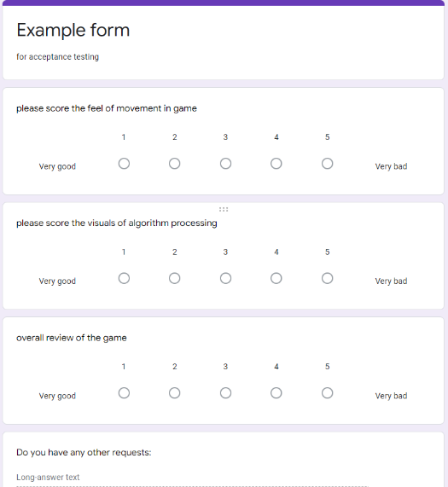I will use googles analytics data to generate an excel file from the inputs I am given, I will then create graphs and other graphics to show which areas of my program require the most improvement, this will speed up the development process for creating the next update for my project.

My stakeholders will also be given a beta copy of the game and the questionnaire to ensure I have constructed the software they are looking for in response to their feedback.

I am hoping that the data gathered from this questionnaire will enable me to get some insight into what my customers are after from the game and if there are any areas, I can add features before the release. By releasing the game before its official release in a beta state I will gain a lot of testing data which I aim to use to negate as many bugs as possible before the release.

# Implementation

In this section of my project, I will begin to program my design and develop my ideas, I aim to use PyCharm, combined with PyGame as my IDE as it contains many built-in libraries and graphical capabilities as well as other features to assist with the development of my game.

## Key tasks for implementation:

* Create a maze with walls à create a maze generation algorithm
* Create a moving sprite à create an algorithm-controlled sprite
* Create a start page à create a fully functional graphical user interface
* Code a working parent class for the algorithms à code all of the individual algorithm

I am going to approach the implementation of my game iteratively. The approach I will take to achieving the implementation tasks is described below:

### Program #1

This working prototype version of the game will be very basic without a start menu or other unnecessary features, I will be focused on producing a window with a keyboard-controlled sprite.

This program will have to be tested quickly to ensure I can send a working prototype to my client. However, once the prototype is complete the difficult starting process will have been done and the focus will shift to testing functionality, ironing out imperfections or further requirements which may be mentioned by the client and developed during the next iteration.

In this working prototype version of the game, I will create the maze wall class and then once collisions are implemented, I will create the maze generation algorithm. I expect the maze generation algorithm to take a long time to implement as it will be the first time I have done this, as I have never implemented an algorithm. To ensure careful execution of this phase, I will be leaving plenty of time to code and test the maze algorithm and will build in some extra time for fixing any issues. [here]

### Program #2

This program will be the final version of the game, including all previous versions and an additional start menu. In this stage it is important to note I will be completing all of the maze solving algorithms. Finalizing the project is expected to be complex as compiling all the different modules may cause some errors and require significant testing to ensure all modules of code work well with each other, and there are no overly intrusive bugs. [here]

### Program #3

This program will be the final version of the game, including all previous versions and an additional start menu. In this stage it is important to note I will be completing all of the maze solving algorithms. Finalizing the project is expected to be complex as compiling all the different modules may cause some errors and require significant testing to ensure all modules of code work well with each other, and there are no overly intrusive bugs. [here]

## Coding:

In this section of my implementation I am going to be showing the development of each individual module in choronological order, note that the end of one module may be made half way through another module so it is only choronological when each module is looked at separately. I have left comments on the code screenshots which should help explain what each section does, however for more detail I have also written a description about every piece of code.

### Maze_Game:

In this module I plan to write the bulk of the code, this section is specifically responsible for: the player entirely including movement and collisions, the window where the game will be displayed including rendering and dimensions, the input keys and input buttons, the high score feature including recording and storing the time.

#### Initializing the program:

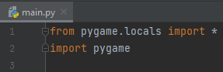in this screen shot I have added the PyGame library to my program and setup my editor PyCharm to function as intended, pygame is a library I

have never used before but contains lots of features, specifically: graphical, rendering, and collisions which should make game development easier such as implementing a screen to display graphics on.

#### Text Description automatically generatedCreating the player class:

This is a class I have made using object orientated methods this code should work with the next few segments of code allowing it to be called and passed correctly, this class aims to define how the character movement will work within the maze for now I have set the movement to work within a 10x10 grid however I will be modifying that to be a variable later on in my development. The methods “moveXXX” will be able to be called by other areas of code when I

. implement “KeyDown” actions, coding the movement to be carried out by methods makes it easier to connect both the users keyboard controls and the algorithms built in controls to the same sprite within the code.  
  
In this section I made the previous movement section actually work as none of it had object orientated parameters it needed to run I started with this code which would allow me add methods for things such as “key Down” detection and creating a window for the game to run within however that has not yet been added.

#### Setting up keyboard buttons:

Here I am going to use Pygame as it provides a straightforward and intuitive way to handle keyboard inputs, making it easier for me to implement. Pygame's event handling system allows me to capture keyboard events, such as key presses and key releases, and connect them to specific game actions, such as moving the character in the maze.

Secondly, Pygame offers flexibility in handling keyboard inputs, allowing for various types of input customization. Developers can define their own key mappings and easily change them during runtime, providing the ability to implement custom controls and keybindings. This allows for a personalized and immersive gaming experience, as players can use their preferred input methods to navigate the maze and control their character.

Furthermore, Pygame's support for simultaneous key inputs is advantageous for games with complex controls. It allows developers to capture multiple key inputs at once, such as pressing multiple arrow keys to enable diagonal movement for the character in the maze. This can enhance gameplay and enable smooth and responsive character movement, providing a more immersive and enjoyable gaming experience.

Finally, Pygame's event-driven architecture for handling keyboard inputs allows for efficient and optimized input processing. Rather than constantly polling for input, Pygame waits for events to occur and then triggers corresponding event handlers, reducing unnecessary CPU usage and improving performance. This can be particularly useful in games with fast-paced gameplay or real-time interactions, where responsive input processing is crucial.

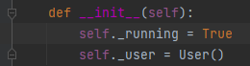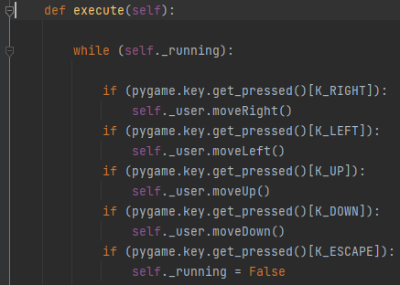This is a method I created to allow the movement actions to be called by the user pressing down on the keyboard arrows it uses a pygame function not normally included with python

“pygame.key.get_pressed()[KeyName]” is the code required to read keyboard and mouse inputs and now the player should be able to be controlled once the players character is implemented correctly

#### Setting the display up:

Here I am going to use Pygame as it provides a simple and intuitive API for game development, making it accessible for inexperienced developers like myself. So far, I have been impressed when using pygame in my development as it appears to contain the vast majority of features my program will require and will reduce the bloat of adding lots of different libraries with different APIs. Pygame also offers a variety of features for graphics, animations, inputs ,and sounds. These features will speed up my development process as they are required throughout my software. Additionally, Pygame allows for cross-platform development allowing for the game to be ran on different operating systems without the program having to be rewritten.

Furthermore, Pygame's ability to handle graphics and animations in real-time makes it well-suited for creating interactive games with smooth and responsive gameplay as will be required in this program. Its support for hardware acceleration enables fast rendering of graphics, making it ideal for rendering maze layouts and character movement. Additionally, Pygame provides collision detection and physics simulation capabilities, which are crucial for implementing maze traversal and character interactions. 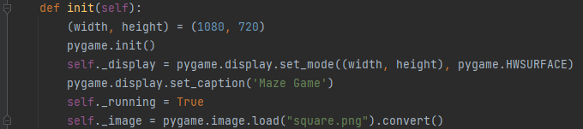 In this section the most difficult part so far was setting up the “._display” after doing some research I had this code which creates a window with a moveable square and the application has the title Maze Game

This gif shows the current state of player movement, currently it is too fast, and the sprite can travel out of the bounds of the game window. As I attempted to demonstrate in the gif here <<<

I am going to implement a system to allow a maze to be randomly generated and displayed on screen, this will include a maze generation algorithm. Collisions between the player and maze walls will also be implemented

#### While running loop:

This function will loop constantly throughout the entirety of the game as it runs making sure the application will continue to execute instructions

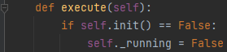

#### Handling events:

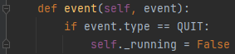This function is responsible for dealing with new events, so far this only includes closing the game.

#### Player movement + collisions:

this is the final iteration of player movement. Below are some key stages of development I went through to get the code to this point, specifically the check point and check collision sections. However, in summary the player movement in this game works by increasing or decreasing the existing (x,y) coordinates, and the collision is checked for each face of the square plyer model but only if that side is being moved. For example, pressing the up arrow will check if the top right and top left corners of the player model will be within the boundaries of the maze after the movement if true, then it will move the player upwards by changing the y coordinate this means that the collision detection actually runs before the player even moves creating a collision with no jittering or clipping. 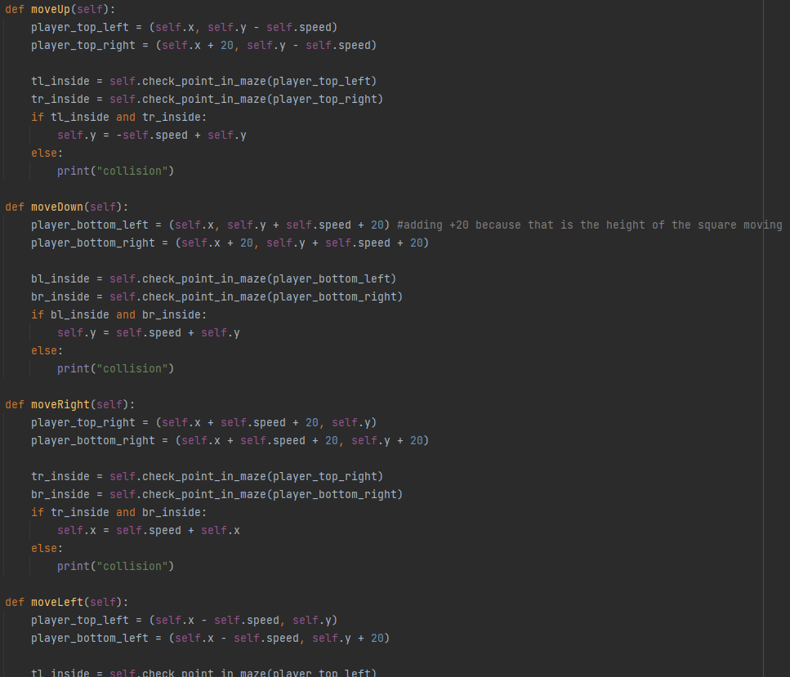

Check if a point (player) is in the maze:

### Ongoing remedial testing:

Currently player movement is not working correctly, the sprite is only able to move for around 10 pixels upwards before becoming completely “stuck” left, right, and down don’t work at all despite the code being changed so they are expected to function correctly. I currently think I need to be able to check if the points on the player are within the coordinates of the maze not just the specific points of each wall tile which is the current way collisions are check as shown here:

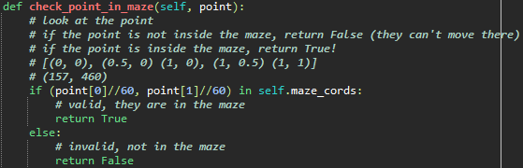

The comments on the code should help explain how this system is meant to work. 

After some debugging, I was able to find a possible error, the points on the moving character are passed to the collision check in a non-standard format meaning they cannot be read properly making collisions not work as intended.

I also spent some time changing the character sprite to a .rect from a .png however that created the exact same error so I didn’t think it was worth adapting the entirety of the code to facilitate this change so reverted it.

#### Collisions:

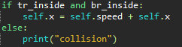I added this print statement to allow me to see when the code is detecting a collision with a wall as well, so far only the moveUp function detects walls. Sometimes, specifically the “midpoint” walls are not detected however allowing the character to travel through them. It is still unclear why this only happens occasionally. I fixed this problem a lot later in development, here is my documentation HERE

#### Colouring the maze/rendering squares:

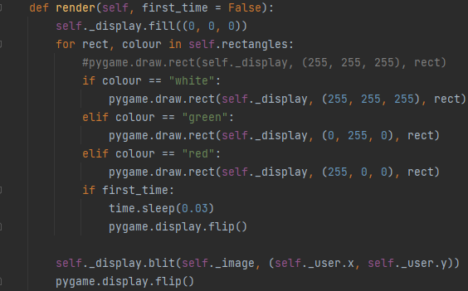Most of this function was written once most of the maze_generate code was complete however the .display lines where written early on in development, the large if statement is to check what colour is attached to each coordinate and make sure that the correct colour is being displayed for its position, so far have decided to make all of the midpoints white and the corners green to assist with the debugging of my code as collisions are still not working as intended, the time.sleep(0.03) is the amount of time the program will take between drawing the coordinates onto the screen creating a satisfying visual.

#### Turning pixels into usable coordinates which are the dimensions of the walls:

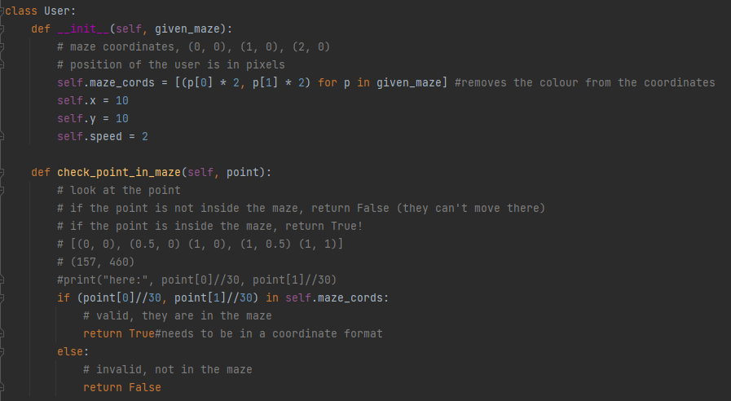

Ongoing remedial testing: I fixed the collisions errors by changing the points of the character from pixels into coordinates (green boxes) so that they integrate with the maze walls better I did this by doubling the variable for the point in pixels so that all points where whole numbers. This did take quite a lot of time and debugging. I decided to leave the debugging code commented out but underlined in red for easier understanding, the sections in green boxes above are essentially multiplying the coordinate x and y values by two and then dividing by 30 which is the length in pixels of the walls used in the maze

after coding the maze_generate module this is the current state of the game, collisions work perfectly with no jittering or clipping at corners. I think it looks very satisfying which should help make the game more engaging. There is a red mark at the end of the maze that I will program later to take you to a menu screen.

##### At this point the first prototype is complete.

### second Iteration:

At this stage I plan to implement my path finding algorithms into my previously create maze, I am going to implement A* and Dijkstra’s algorithm. I plan to make updates to the GUI to make it more user friendly

#### Extra animation code used to make a graphical representation of the information needed for Dijkstra’s:

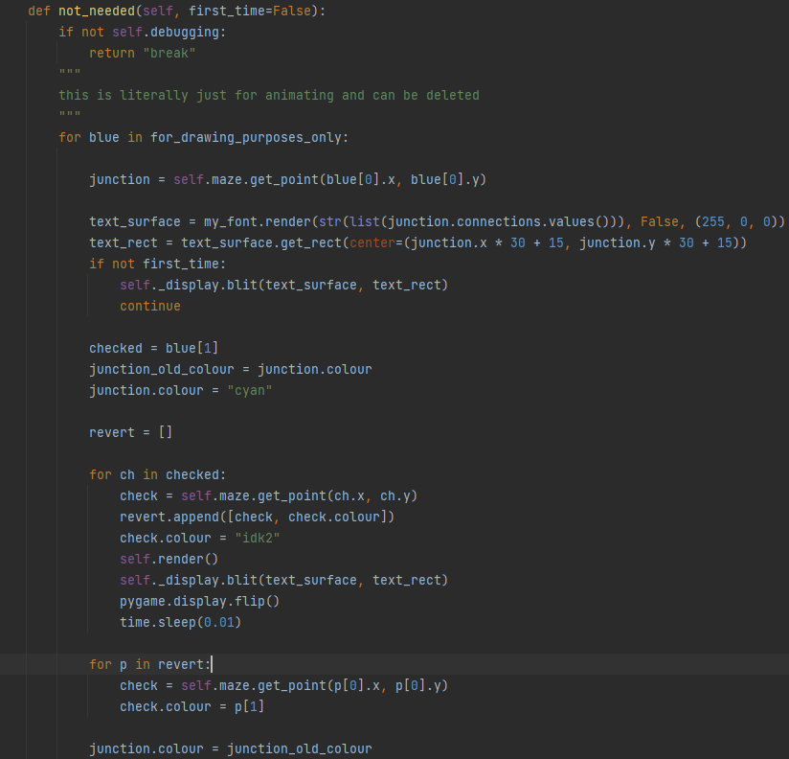

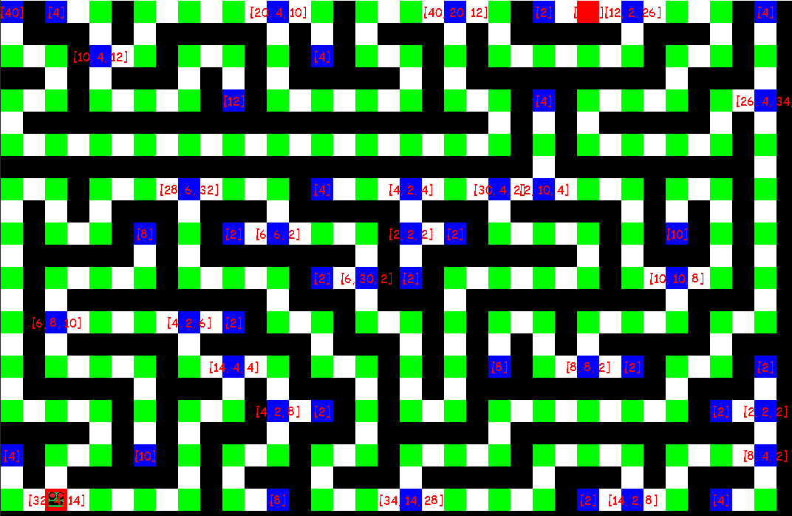I added this section of code to display the information I have coded in a simple and graphic manor instead of just being left with a load of variables which I find very difficult to make sense of. This section of code is completely unnecessary

so I am going to not use it in the main version of the game unless “debugging” mode is turned on however the information this function displays is still crucial to the program and included in the “Maze_Generate” module.

When the “not_needed” function is finished running it marks all the dead ends and junction in dark blue and also marks them with the distance from the other nearest dark blue points, this information will need to be passed to Dijkstra’s algorithm. I’m glad I made this function to display the information I’m finding it really helpful.

#### Creating a welcome screen:

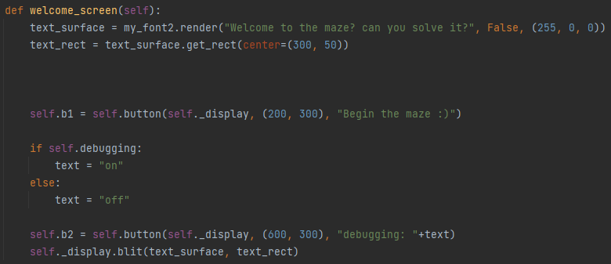

Here I decided to add a welcome screen to my maze game as I knew I would need to code a menu at some point and wanted to do something easier than implementing Dijkstra’s algorithm as soon as I finished the maze generation. At this point the menu is incredibly basic and consists of just a black screen with some meu text and some buttons which I took from a source online [8]. I think they’ll look quite nice.

#### Creating buttons:

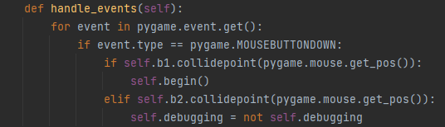

I created this function to handle the MOUSEBUTTONDOWN feature of pygame, the code was included in the online button file mentioned before however I thinned it down significantly as my code already featured many of its features. Below is a button I copied from an online source and then altered to suit my needs

### Testing to inform development #1 / ongoing remedial testing

I have come back to this section of the program and decided to modify my button code and carry out some testing to ensure it is working correctly as the previous version had bugs, I have used some basic button code I found online, however, I have modified the size, colour, font and position to ensure the button suits my program. I am mainly going to test how well it is implemented in a test so I can be confident it will work reliably in my game.

Here I have setup a button function to use the colours, sizing, and text I want to use, this function will allow me to easily create multiple buttons of the same style quickly and easily. The buttons will also be able to switch between a low- and high-resolution mode to save on processing requirements as I found problems later on when testing my game on low end hardware: 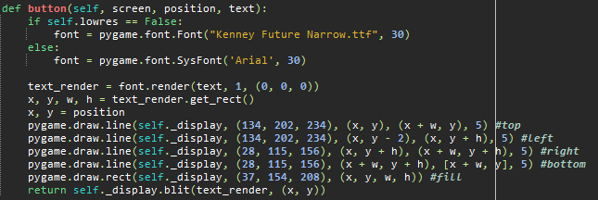

I created a simple menu to display a button in graphics:

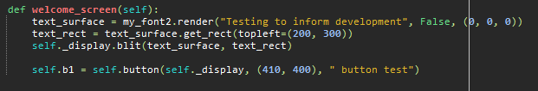

This is a snippet of the output screen I quickly made for this test:



I have connected this button to a simple print statement to see if it is implemented properly:

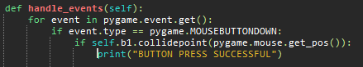

After pressing the button, the print statement provides a successful test output:

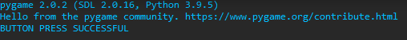

Overall, I am happy with this button implementation notes: there was no latency, the pygame feature MOUSEBUTTONDOWN avoids a bug where left clicking buttons was causing crashes, there was also a bug where clicking anywhere on the menu BUT a button would cause crashes, I mitigated this with the following if statement:

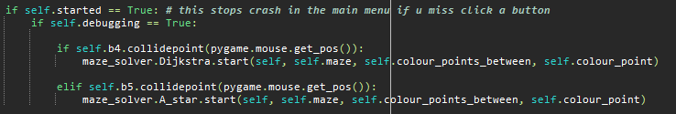

The buttons for in game features e.g., starting the path finding algorithms are contained in the “if” statement ensuring that they are not checked for unless they are initialized when “self.started” is true.

### Back to coding:

#### Recognising a completed maze:

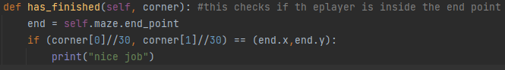

This section of code checks if the corner of the player is touching the “end” square and prints “nice job” later I will be changing the print statement to take you to a “next level” or “quit” menu page, this function is called within the “move_(left, right, up or down)” functions and the corner passed to the function is the one on the face of the direction of movement.

#### Displaying the maze and player on screen:

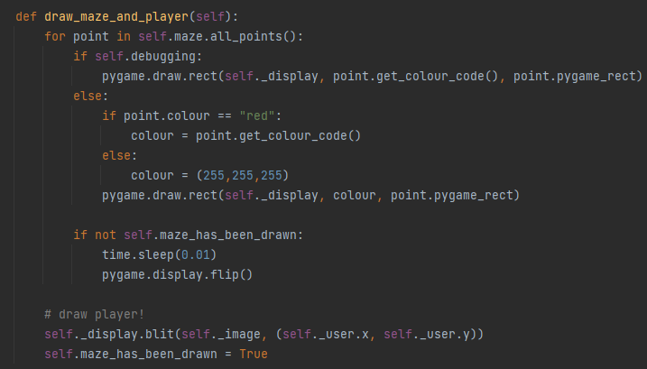

Ongoing remedial testing: This section of code has been created to fix the bug stopping the maze generation from being animated It does this by checking a variable “maze_has_been_drawn” to see whether it’s true or not.

This code is also responsible for the colouring the maze starts and end points red when debugging mode is turned off whilst leaving the rest of the maze white.

#### Logging time:

After I had a working maze which is capable of recognising collisions, I decided to implement the ability for the completion of the maze to be timed and stored in a permanent storage location.

First, I started by experimenting with the python “time” library as I’ve never used it before and recognise that the test will help inform my development, I created the following code to see if I could log a time value between two points in time as that is what I will need for the start and end of the maze:

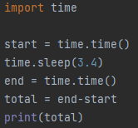 I generated the following output, and I am satisfied with the accuracy of the output. I am going to expand this idea when implementing my “log_time” and “has_finished” functions.



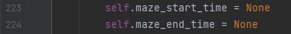 This section of code just adds the variable locations to the user class

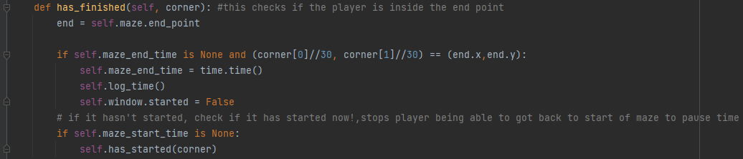  
Ongoing remedial testing: I encountered an error where the player could restart their time by crossing the start point again, I altered to “has finished” function to log the time from when the player touches the end square, I also implemented an if statement to make sure the player cannot restart their time by going back through the start point.

Then I implemented a function to start the time recording when the player leaves the start square

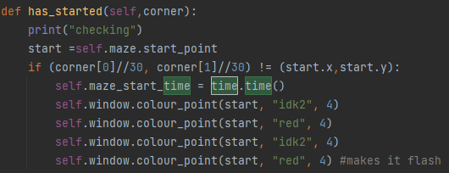

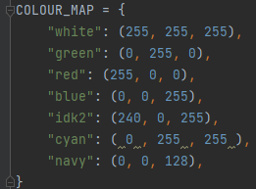I also decided to add a quick flash so that it is easy to see when the start point has been left. It uses an expanded version of the colour map from the maze_generate module as shown on the right >>>

I then added a clear times button to the menu screen so that saves can be reset and attached the button to the following function

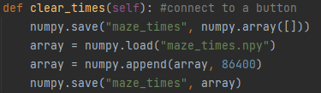

This will delete all the times in the file and create a new time of 24 hours, as it is only the lowest score, I plan to display so starting the array on 0:00:00 would make the high score unbeatable.

Then I created a simple text output on the menu screen displaying the high score.

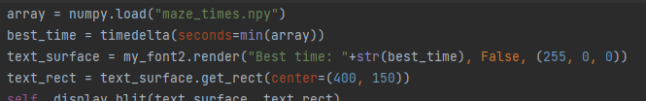

The output of the following code looks like this after the scores have been reset although I had to also add the “datetime” module from delta time to get the correct formatting

this value updates after every game and is stored even after the local machine is powered down entirely.

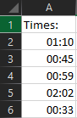Each maze completion will result in its time being recorded and added to this array which will be updated once each maze completed. Once the maze is completed the values are stored in minutes and seconds (mm:ss). Storing data like this would also make it easier to create an online live high score leader board on a server if the game gained significant popularity or got invested in by an external game producer. I may decide to add a table relating this one to the username of the player if it becomes necessary for high score comparison such as a leader board. Please note that the array is not sorted, and it is the roll of the program to select the lowest value to display a “high score”.

### Early GUI

#### Graphical user interface Description automatically generatedMenu:

this is the state of the menu contains a debugging on/off switch which changes based on the current state, this has since been updated, please view design lower in document or follow link here

#### Colouring/animating:

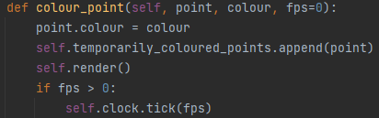This function is used by the Maze_solver module its purpose is to allow the software to change the colour of individual points such as junctions to allow for a satisfying animation when the path finding algorithms are ran.

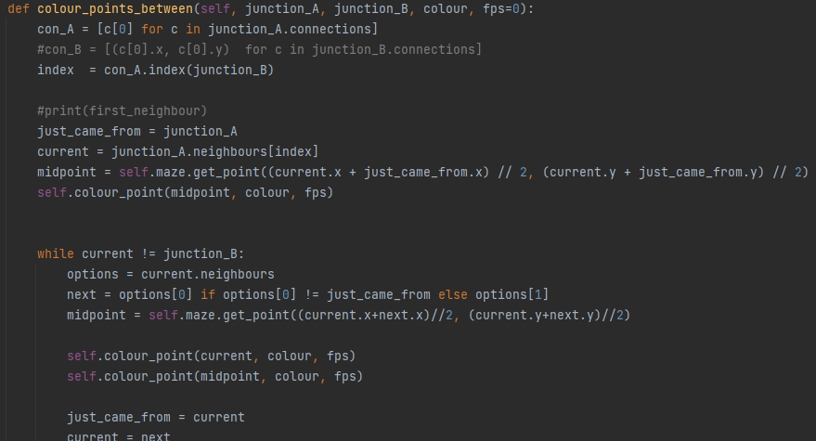

This section of code is the bigger brother of the previous function, it takes in the information of the current junction and the information for the next junction and colours all the points between. Note that I had to add the line of code in the red box as the only points being coloured where the primary points in green, because this game treats midpoints as if they are just a “place holder” for the primary points to connect they were not included in the “current” object.

#### Adding and fixing buttons:

I added more buttons later on in development as I needed to allow the player to run the two pathfinding algorithms in game. In the code above the buttons 4 and 5 are within an “if” statement meaning they will not be checked if the game is not loaded in as these buttons are not in the menu but on a separate screen. This was causing crashes whenever the user clicked anywhere BUT a button when in the menu as the if statement was looking for button 4 and 5 but they are not initialised until the game is running. The if statement in the red box fixed this issue.

### Ongoing remedial testing:

The box in blue was added to resolve the bug where the path finding algorithms where still functional in the debugging == false state of the game, I did not want the algorithms to be used to cheat in the game and gain faster high scores. Also as the debugging false mode of the game does not use the colour map the algorithms were running but invisible creating unnecessary lag until I implemented this patch.

### Maze_Generate

Here I created a new .py module to add to my project, called generate_maze I had to import random for a section of the maze generation.

#### Initializing the maze:

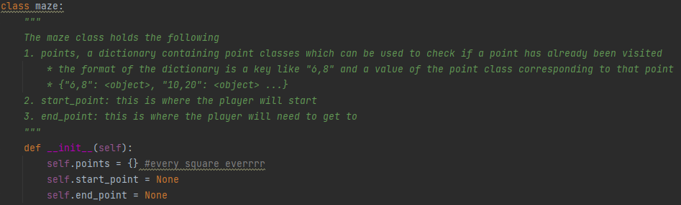looking at the screenshot above ^^^ you will see that here I have created the maze class and created its key variables, these are explained in the comment in green however I will go back over them in more clarity now.

Self.points is a dictionary which aims to contain both the position in the format (x, y) and the object so that the software can know what to draw and where to draw it, this is enough information to store the entire maze however it would have no start or end point.

Self.start_point is simply the position of where the player will start, this will be a red square and will flash as the player leaves the square starting a timer

Self.end_point is also quite simple as it is just the finish line for the player, once reached the game will exit to the main menu and the time will be recorded, if the time is the new high score, it will be displayed on the menu and saved.

#### Placing points/walls:

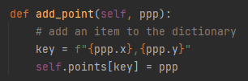this function is responsible for adding a point to the points dictionary, it will be called as squares are being generated for the maze.

Fetching points/walls:

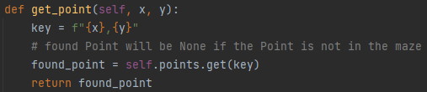

This function will be used to get the current object at a given point from a set of coordinates and return it.

#### Storing walls and “special” points:

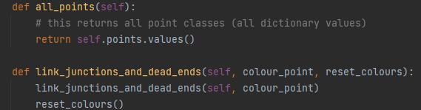

The function above “all_points” will return a large dictionary with all the values in

However, the function below “link_junctions_and_dead_ends” will change the colour of the squares which are dead ends or junctions to pink. However, I only want to call this process when in debugging mode and the vertexes to be coloured are in the “snail trail” of a path finding algorithm as show below.

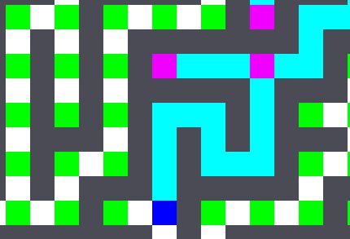The result of this function is on the left, as you can see, I have left the non-visible junctions their standard green colour, but for visible junctions or dead ends they are navy blue and for searched junctions or dead ends they are pink.

#### Text Description automatically generatedColours:

This is the colour map also contained within the maze class, it is in the dictionary format and provides colouring information for specific colours so that my maze will have nice graphics and animation.

#### Giving every single square that is walkable the information necessary for algorithms to work:

The following section of maze_generate is within the Class “point”, a point is defined as any square which can be moved on also known as the path.

As you can see below there is a large green comment describing what this class does. The main role of this class is to provide the algorithms with the information on what each junction/dead ends neighbours are, this will 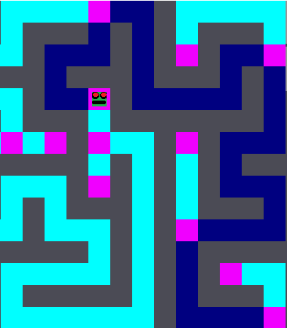allow the algorithms to know where to go and how they got to each place so that a final clear path as shown in navy blue can be created. This data is called connections.

The information called neighbours is simply the squares directly next to the junction as opposed to the junction at the end of the path, please note that the neighbours are exclusively green squares and not white as white squares are only a midpoint to the actual green points.

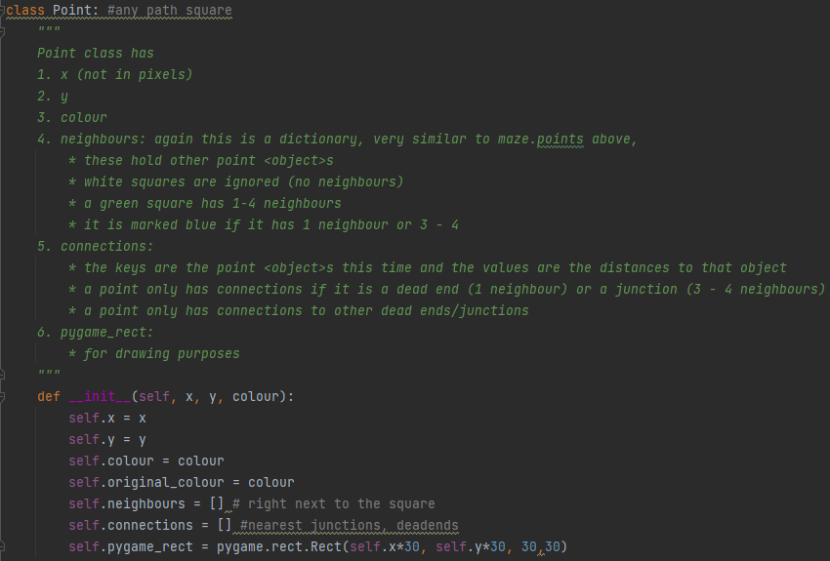

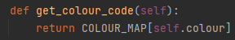This function just converts the colour name to the 8-bit value so that it can be used by PyGame.

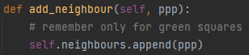This section of code as talked about above only stores direct neighbouring connections between green squares, this function is used to add objects (squares) to that list.

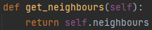This function just returns the neighbour’s array.

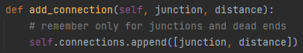This function is similar to the add neighbour function however it also requires a distance value so the algorithm can know how far away each junction is so that it can make a choice depending on the new g_value (distance)

#### Selecting a random unvisited neighbour:

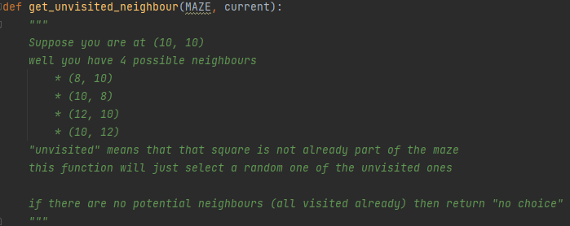This function as shown in the green comment is responsible for fetching a randomly chosen neighbouring square.

The screenshot below was too large to fit here but is a continuation of the function above.

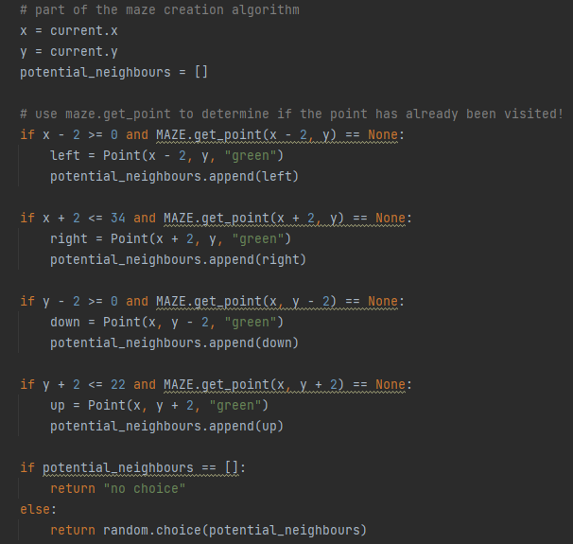

This section of code (above) is responsible for fetching a random unvisited neighbour to the currently selected cell, it does this by checking the coordinates to its 4 sides. If there is a neighbouring cell it gets added to the potential neighbours list and then gets short listed based on whether it is visited or not, then it selects a random unvisited neighbour and when the algorithm has run out it prints “no choice”. This corresponds to placing a red square to mark the maze exit which later will be connected to bring you back to the main menu.

#### Adding the new point and its midpoint to the maze:

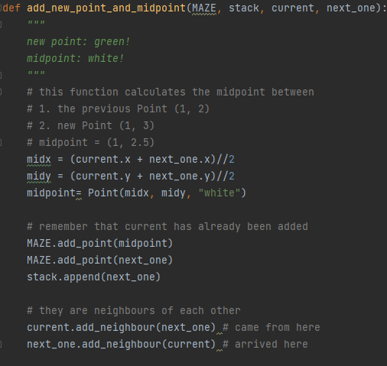

This function “add_new_point_and_midpoint” creates a new wall in between the current and previous walls which have been generated this along with the fact that the walls are always one block apart guarantees there will be no “pockets” – places with a cluster of squares next to each other, it also adds the value “white” which is used by the “render” function in the “maze_game” module to provide a white colour on the maze.

#### The maze generation algorithm:

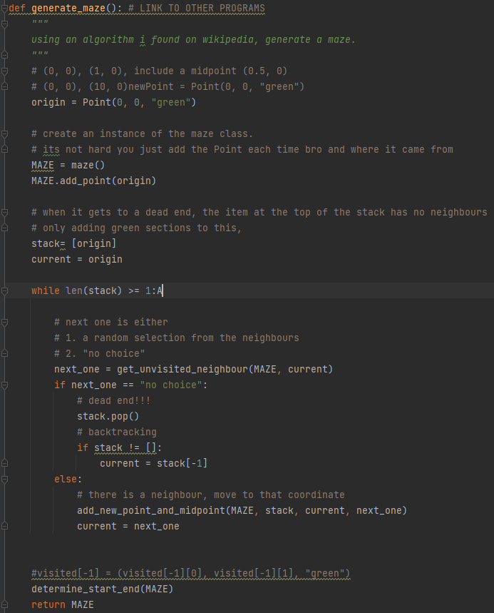

This is the function in maze_generate which puts the variables generated from the other two functions to use. When called, it first creates the first square in the top left corner of the screen and sets it as green, it then proceeds to choose a random neighbour from the two options available as the left and top are out the bounds of the window as declared in get_unvisited_neighbour. After picking a neighbour it adds it to the visited list, it then creates a midpoint between the current and previous squares with the add_new_point_and_midpoint function. There is also a statement checking if there is no choice but to backtrack to continue the maze generation where it will backtrack to the next available branch point and begin from there until eventually it runs out of backtracking options and stops generating, the program also takes the last coordinate of a wall and changes it to be red to mark the end.

The function below is responsible for ensuring the start and end point within the maze are at least 20 squares away from each other to ensure the player cannot spawn right next to the endpoint. It does this by randomly picking two points and then calculating their distance apart using Pythagoras theorem (in the red box) and if the distance does not meet the 20 square requirement it makes another random choice until eventually one satisfies the criteria.

#### Ensuring start and end points are a reasonable distance apart:

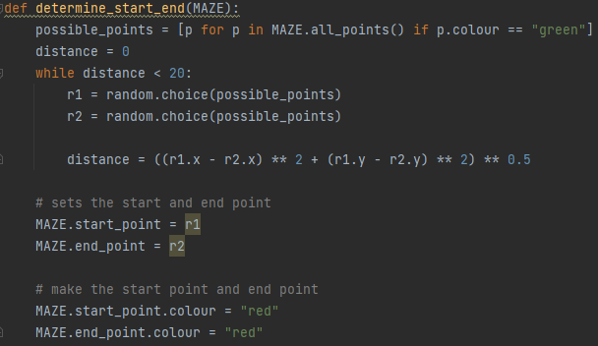

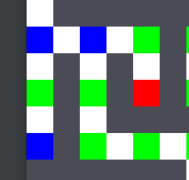The purpose of the function “get_connections” is to provide the maze generation algorithm with the information of where all the junctions and dead ends are within the maze. As you can see from the commented-out code in the blue box this is a graphical representation of the information >>

The for loop below that code is responsible for moving on the junction or dead end (JorD) variable to the next junction or dead end and to make the current point a random neighbour of the previous point.

#### Add the connections of a point to the points object:

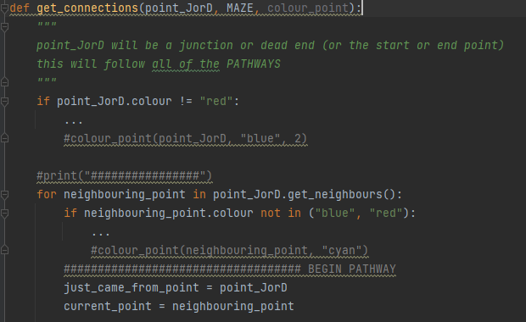

The code below is the rest of the function, above is within the for loop above. By reading the comments this section of code should make more sense but essentially this section is responsible for moving the generated maze path on by two squares as long as it has no reason to stop e.g., generation has reached end point. The if statement in the blue box is specifically responsible for stopping the generation going back on itself.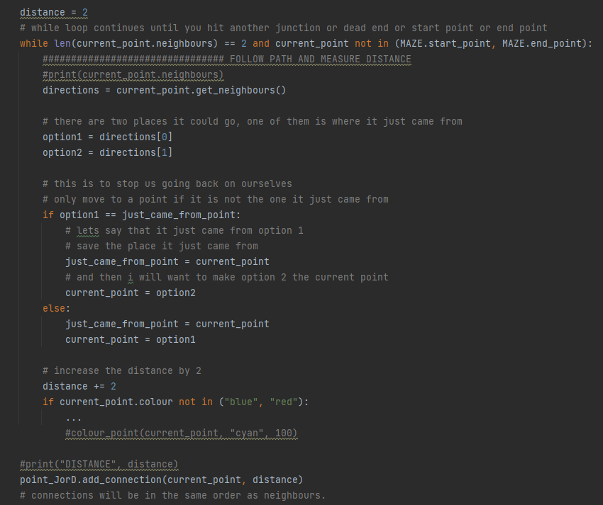

#### Adding a point’s connecting junctions and dead ends to the points object:

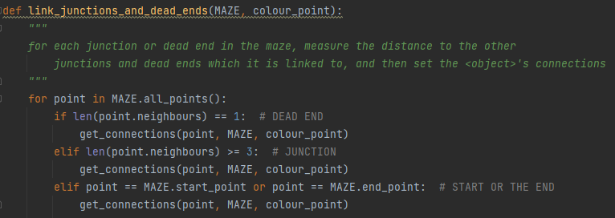

The function above is simply responsible for calculating and storing the distance from every junction/dead end to their neighbouring junctions/dead ends. The for loop above is responsible for determining whether the point in question is a dead end, junction, or the start/end point. This is called in the “begin” function within the “Maze_Game” module.

### Maze_solver

This module is going to be designated to the path finding algorithms which need to work within the maze, crucially a lot of the algorithms need more data to work with than what I have already provided them with. In particular they need the neighbouring coordinates they are allowed to move to, to be stored alongside the coordinate of the square they have selected.

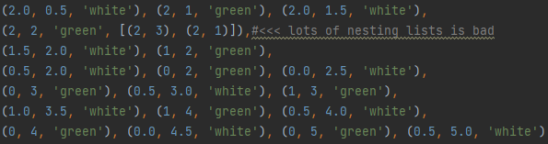It is inefficient and bad practice to have lots of nested lists to store something as large as every individual coordinate neighbouring coordinate, so I’m doing a class instead. This will allow me to store lots more data far more efficiently and effectively.

The first maze solving algorithm I plan to implement is Dijkstra’s algorithm. It took a lot of time to learn the theory behind the algorithm and how to properly implement it however I found that my flow diagram and a source on Wikipedia[9] helped explain it very well.

#### Creating Dijkstra:

Using this information, I setup the Dijkstra’s algorithm class.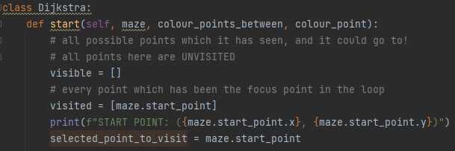

As you can see from the comments the array “visible” was created to store all the possible available points which have never been visited.

Visited stores every point which has been visited/selected by the algorithm. Note that this needs to be initiated with the maze start point inside so that the solver does not double back on itself at the start.

I then began coding a while loop that would continue to iterate as long as the selected point was not the end point. Note that I have added 4 print statements to assist with debugging, however I will be commenting out all print statements in my final version which I plan to release as a .exe file.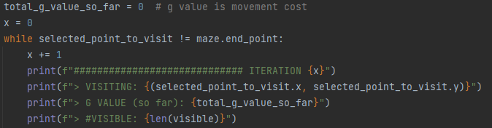

Below is the code required to calculate the g value of the current point being analysed by the algorithm. The most important job this code does is adding where the junctions being searched came from so that the algorithm knows which points to connect in a line (like dot to dot) to show the final result of the algorithm.

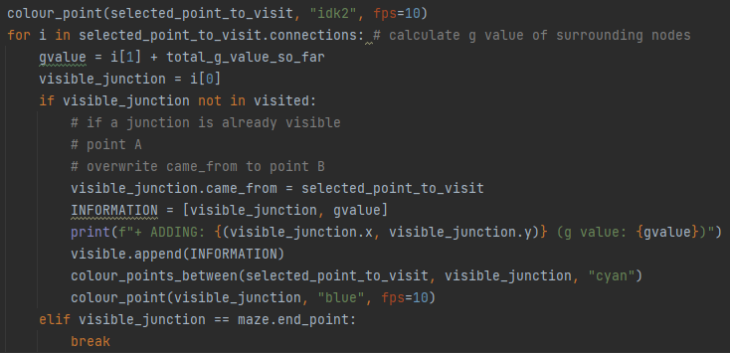

Note that the code within the red box is simply for nicer animation and does not contribute to the function of the algorithm.

The line of code using lambda is and anonymous function and takes the smallest value from the INFO array I found this out from a forum solution online and still don’t understand it completely however it works perfectly for the task.

Not here that smallest_g is the smallest distance to next junction or dead end and also contains the name of the next junction.

The other jobs this segment completes are to remove the smallest g value form the visible list and then add the name of the nearest junction to the visited list as it is visited.

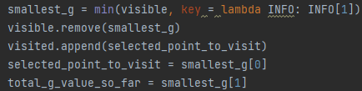

This section of code below is outside of the while loop so only starts when the maze is solved, it then outputs a “success” message for debugging purposes as well as the distance it took.

The while loop also contains calls for the colouring in functions made in the Maze_Game module which create a navy-blue line to from start to finish.

Note that the extra line that seems to repeat itself outside of the while loop however this was necessary to fix a bug where the line would not draw the very last junction to the beginning square.

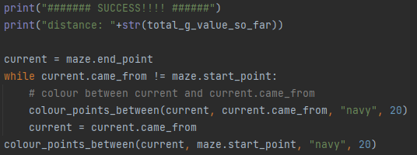

After connecting my Dijkstra’s algorithm implementation to a button, I made earlier and ran the program. It was a successful and ran with no lag or stuttering, I am very happy with this feature and how it has performed in practice.

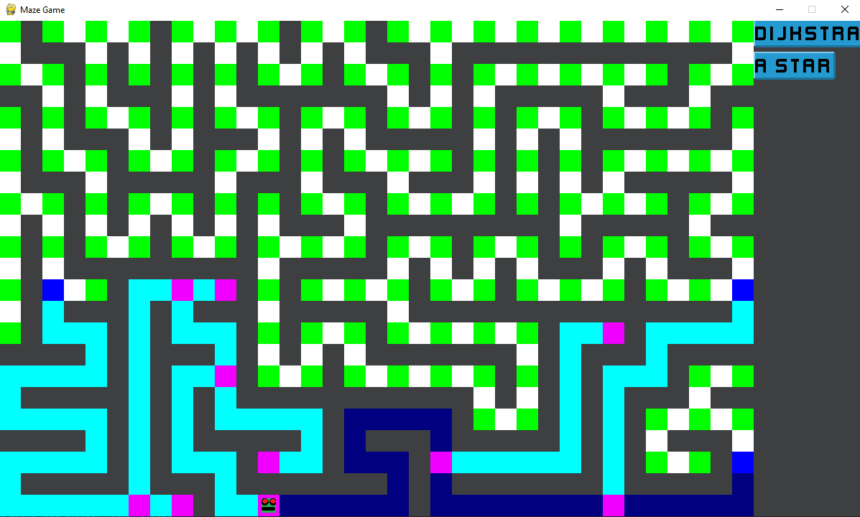

#### Creating A*:

The A* algorithm is very similar to Dijkstra’s algorithm in requirements, so I found it easier to implement A* as I had gathered an understanding of how to implement algorithms after spending so long on Dijkstra’s. A benefit of using OOP in this program is that using Dijkstra’s well-structured modular code it could be implemented here too.

Below is the first section of the A* class first off, the function “heuristic” in the red box is responsible for creating a h_value (the estimated movement cost from the current position to the end point) this is calculated with Pythagoras theorem.

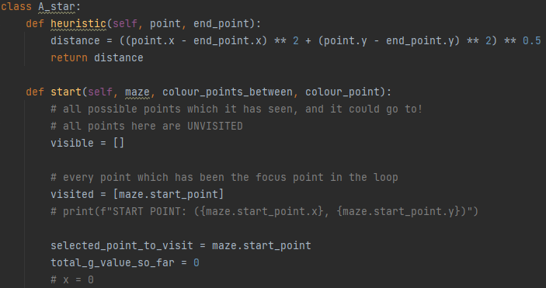

The function “start” above is the entirety of the algorithm at first, I just initialise a few variables, they are described in the comments surrounding them. The commented-out sections where simply used for debugging and will be deleted in the final version.

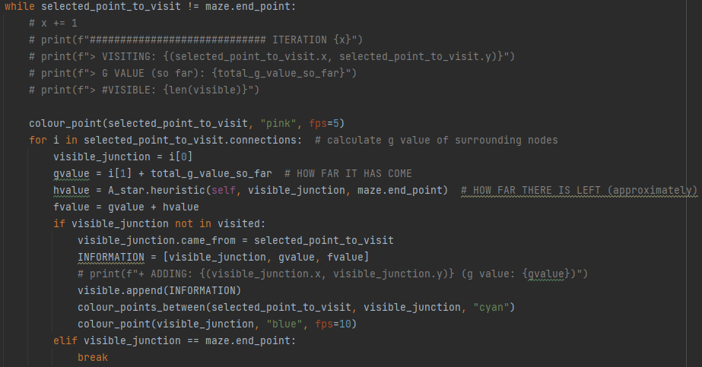

Above is the bulk of the A* algorithm. First is a lot of debugging code which I’ve commented out as it is not required. Secondly, the currently selected point is coloured pink, this means that it is being looked at, (not just visible to the algorithm but actually the current square being processed). In the red box the algorithm calculates the movement cost “g” to go to each of the currently selected squares neighbours and also calculates the distance remaining “h” and combines them to make an “f” value the algorithm will always choose the next square with the lowest f_value.

The section of code in the blue box is similar to the Dijkstra’s algorithm code however in this case it includes the heuristic value which makes A* much more efficient. The code itself is responsible for taking a visible junction that hasn’t already been visited and adding where it came from along with the information provided from the previous section and then colour the current and previous points together in cyan and colour all of the current points unvisited neighbour’s navy blue.

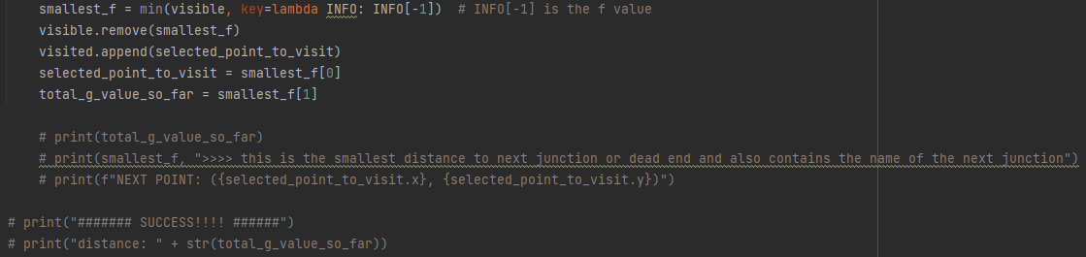

This section of the code above falls within the while loop checking whether the selected point is the end point. This code works the same to the section in Dijkstra’s algorithm however in this case it uses the “f_value” as opposed to just the distance value.

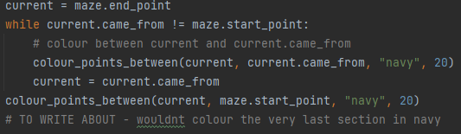

The code above is the last section of the “A_Star” class and also is outside of the previously mentioned while loop, this means that a path to the end square has been found so the rest of this section is simply for colouring and animation.

I then connected the A_star function to a button I created earlier and then ran the program, it ran without error and efficiently found the route without lagging or stuttering. I am very happy with both of my algorithms and am glad I’ve finally finished their complex development.

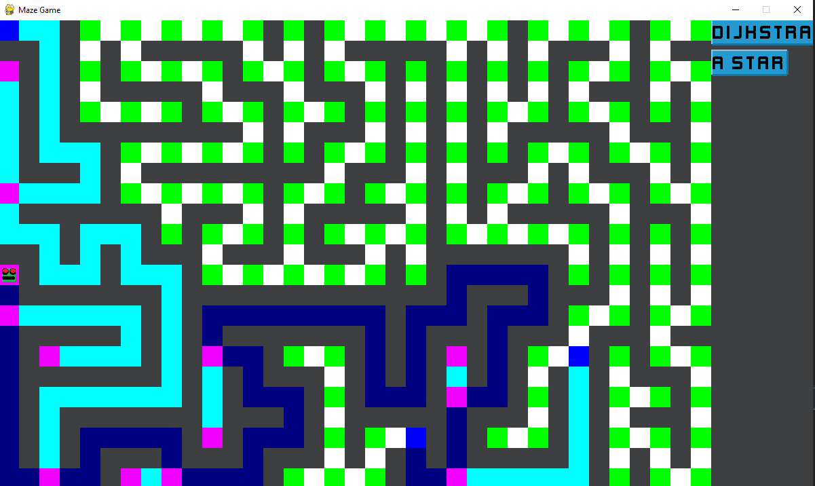

##### At this point the third version of the game is complete

### Third iteration

This section of development will contain GUI improvements with more accessibility features, I will also be adding numerous bug fixes.

Most importantly in this stage I plan to implement a login screen that connects a userID username password and a highscore value in a single record within a database, the login screen must be secure and effective.

#### Making small improvements to the program:

Here I am going to modify the existing program to increase usability, the first thing I am going to modify is the GUI (graphical user interface) as currently it looks uninviting to say the least: 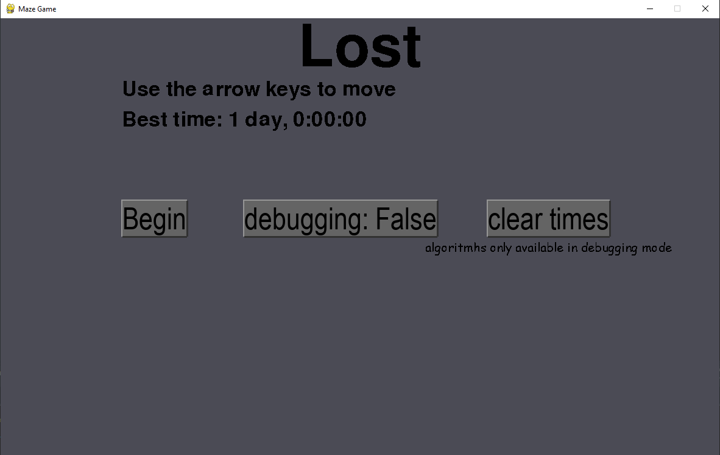

The first thing I am going to do is select a softer colour pallet with child friendly and easy to read high contrast colours I created this colour pallet:



I chose the above-mentioned colours as I needed to create a GUI which grabbed the attention of the user whilst also maintaining a “fun” and “child friendly” style, the colours also allow for easy-to-read high contrast text to be used. I think this colour pallet does a great job of meeting these needs, and I am happy with how the interface looks.

After changing the colour values of the background to Persian pink I think the program becomes much more inviting and stands out a lot.

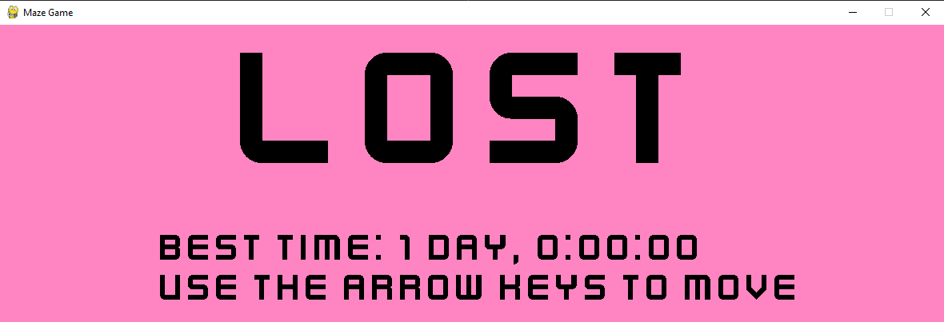

Next, I have decided to change the buttons and fonts. I have changed the buttons to Caroline blue and the font to a custom “Kenney Future Narrow” which gives the interface a modern look.

Ongoing remedial testing: I have noticed performance decrease since the implementation of this text due to it containing many vertices however the performance loss is negligible on modern day computers. But to be safe I have decided to implement a low-resolution button to ensure that people on lower end hardware can still have the same experience as my target demographic for the game probably will not have expensive hardware. To do this I simply added this code:

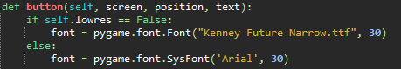

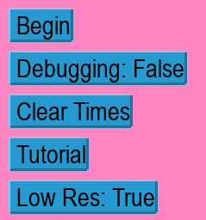and attached it to a toggleable button. When enabled the buttons change the high vector custom text to a standard system font, it looks like this:

I do not like the look of the menu like this as it is so low resolution. This feature is disabled by default; however, this solution was very effective as the game now runs at full FPS on extremely low-end hardware.

I also decided to re arrange the buttons into a vertical stack as it allows for a more compact and minimalistic look whilst maintaining high quality ease of use.

I thought it was also necessary to add a tutorial page to allow new players to gain a suitable understanding of the game in a short amount of time. I opted to keep this tutorial hidden under a button to ensure the menu can still look pleasing and not clustered and also not irritate regular players. I designed the tutorial to pop up when pressed with a short yet detailed explanation of how the game works with diagrams and text. This is the view of the tutorial pop-up window: 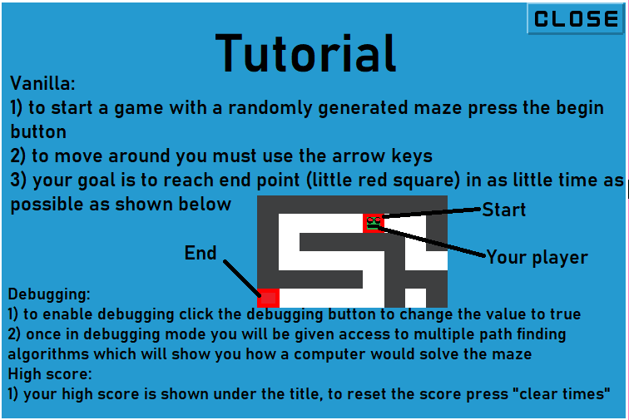

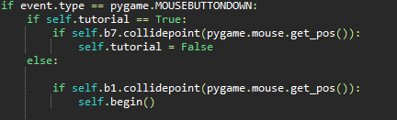Ongoing Remedial testing: After the tutorial was implemented, I noticed the buttons behind it where still functional despite being visually covered, I decided to fix this bug by ensuring the buttons weren’t active when the tutorial was open:

I decided the GUI was complete, this is the final view of my menu:

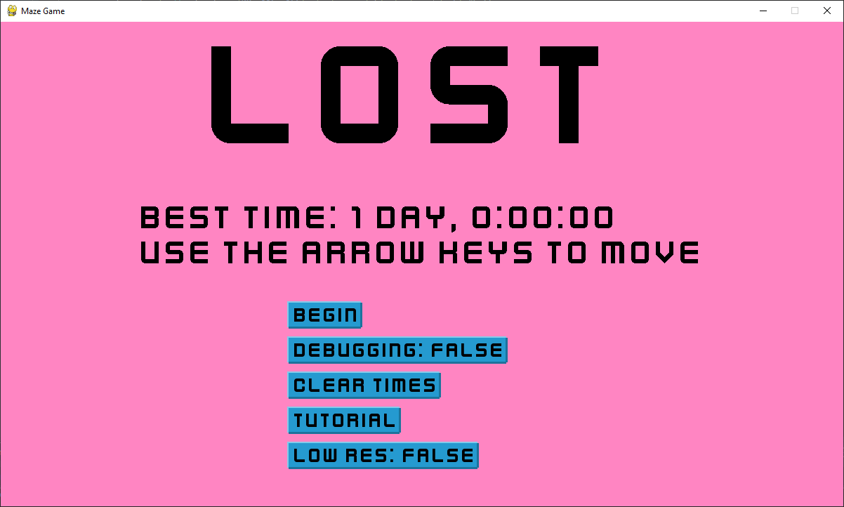Overall, I am very pleased with this menu and find it perfectly suitable for the young audience it is designed for it is also completely functional and has no latency or jittering.

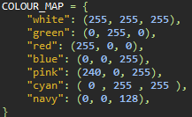You may have noticed the use of informal variable names (e.g. “idk2”) for colours in the above code, I have since changed them all to accurate and understandable names.

#### Conclusion of Implementation:

Below I have inserted gifs of what each algorithm I have developed looks like in its final release state. As a brief explanation of what each colour means within the maze animation, I have made a Key:

**point, midpoint, visited, visible, start/end, final path, search path.**

|  |  |
| --- | --- |
|  | **Dijkstra’s algorithm:**  This algorithm’s philosophy is too always choosing the next square which is the shortest distance to travel from the start point.  This makes the algorithm very easy to run and provides effective results. |
|  | **A* algorithm:**  This algorithm’s philosophy is based on including a calculation on where the next square is in comparison to the end node, this helps the algorithm stop moving away from the end point just because other squares are nearby which is what Dijkstra’s downside often is.  This algorithm does require more processing however as a heuristic value must be calculated. |

## Login Screen

I started by creating a new module in the python file called login_screen.py

### Setting up display

The first thing I did was create the code to create a blank database which can be thought of as 4 columns of userID, username, hashed password and high score, however it is really an array of dictionary of dictionarys. note that this function checks if itself exists and if it does it simply retains the information already inside it.

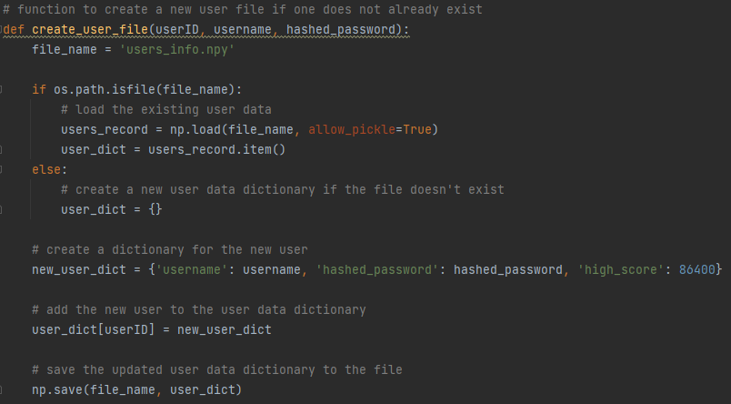

Here I began the creation of the main login screen function, I started by checking if the data base exists and if it does not then I initialise a new database, this avoids the problem of making unnecessary blank record.

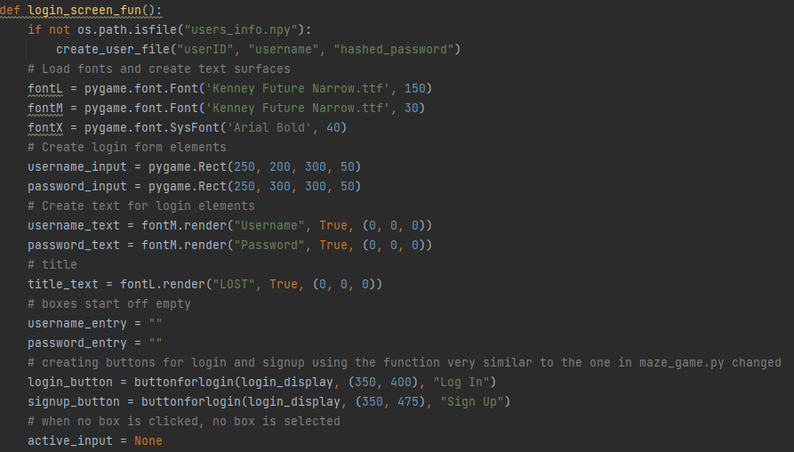

I then went on to add basic variables that are needed to create a nice looking GUI that has the same styling as the main menu in the other module, I simply copied the fonts over. The variables user/pass_input are going to be hollow boxes that the password and username will be entered into, user/pass_text is just the rendering of the words “username” , “password” that will go next to the hollow boxes to mark where the user should enter each piece of information.

The login/signup_button variables are going to be connected to a button function I copy over from the maze_game program later.

Active_input is just going to contain the currently selected input box (user or password) currently nothing has been clicked so its = None

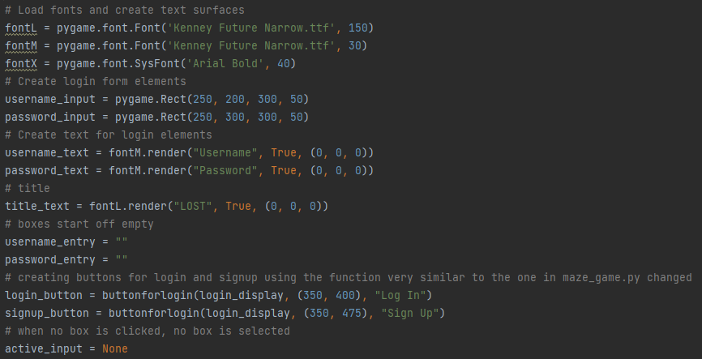

I then finished setting up the display and once I add the button function I will be able to have a full GUI just without any real functionality.

I started by setting the background colour to the same pink as in the main menu. Then I drew the hollow input boxes created earlier and but the words username and password next to each of them respectively

I then created the code to display the username as it was typed into its respective box and also did the same for the password but converted each character to an Asterix for security. I also wrote the code to add a button but need to copy over the button function from the other file.

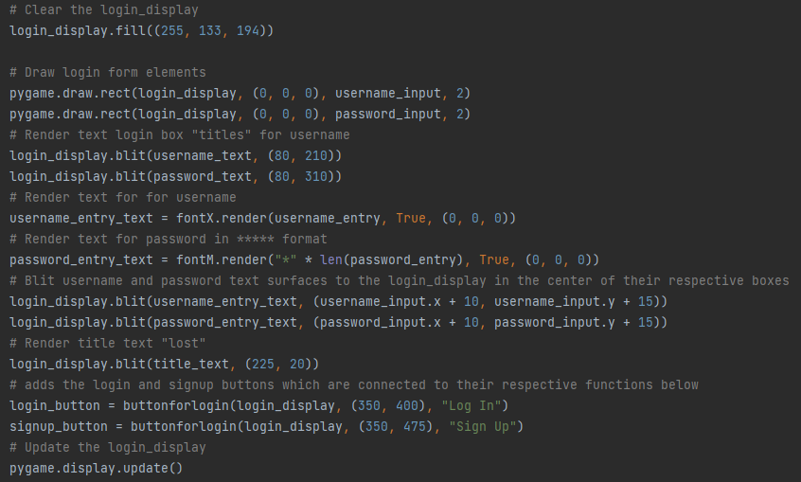

Here I copied over my code for a button from the maze_game.py file but changed the code for the positioning of the text within the button because they looked off centre. But overall this code is almost identical to the other button function.

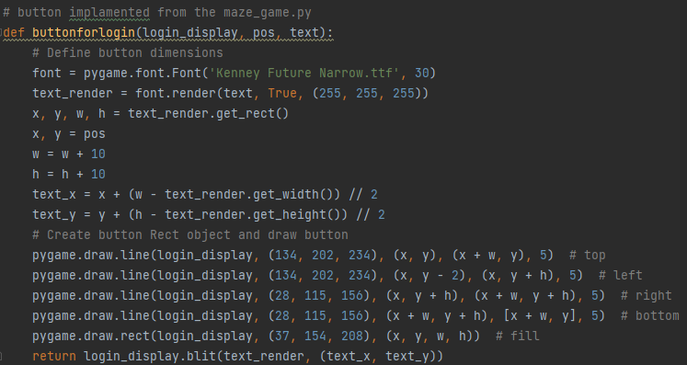

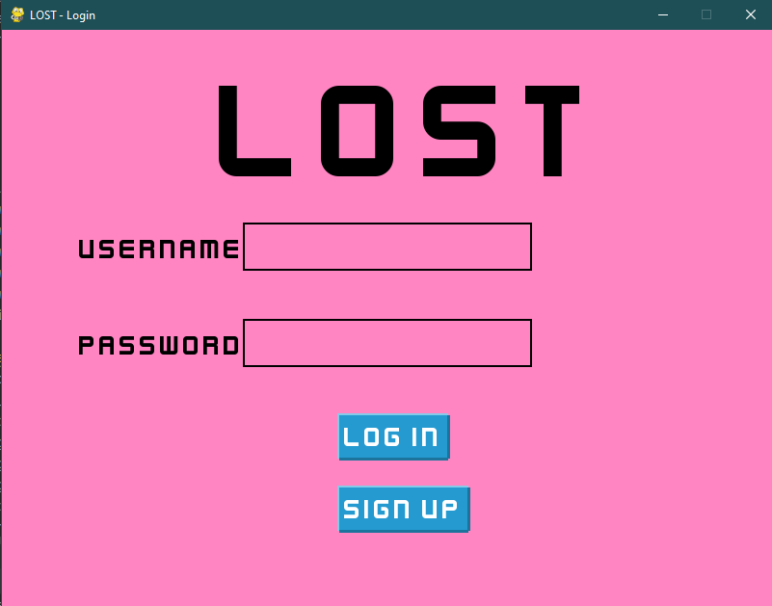at this stage I had a nice-looking login screen, I liked that it opened as a separate window to the actual maze game file as It means that on a failed login attempt the main game is never even opened which I feel makes the game more secure.

So far the login and signup buttons do absolutely nothing but I’m going to change that later.

For now I’ve decided to add the while loop checking for keyboard inputs and have connected all the “special” keys to their respective functions with the pygame.KEYDOWN feature.

Note for the return key I have made the input box switch from the username box to the password box if the username was selected and then from the password box to an attempt to verify the username and password before attempting a login if successful if the password box was selected.

I also added the quit function to both the quit button and escape key.

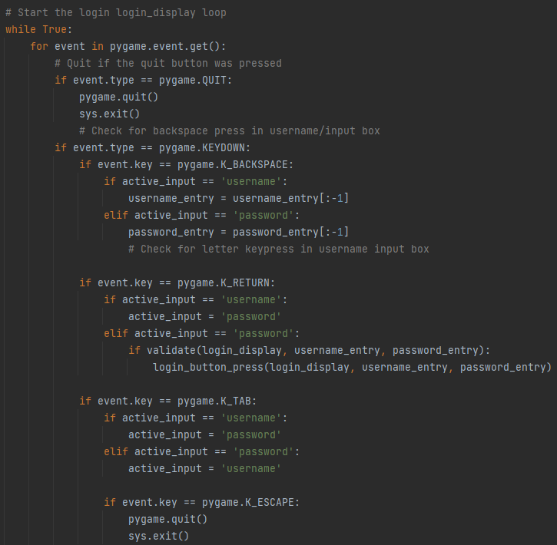

Below I then added the functions for the mouse clicks on the login screen, adding the ability to switch between the selected boxes with a mouse click and then I also attached a function called validate to both the login and signup options and if validation is successful then we can move on to their respective functions.

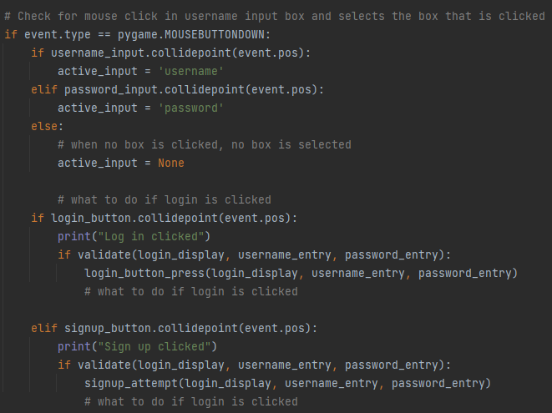

I decided it would be nice to create a function that can display messages for a short amount of time on the login screen so that input errors and invalid inputs can be diagnosed and relayed to the player, I also think they will help with debugging the program.

I started by taking the display and a variable “message” as an input, I decided to use a standard font to ensure this works on lower end hardware as I encountered performance issues in the maze_game program earlier, I first created a text object containing the message then centred it in the screen before putting a box behind it with slightly inflated dimensions to make it look nicer. The message also times out after 1.5 seconds to give the user time to read it.

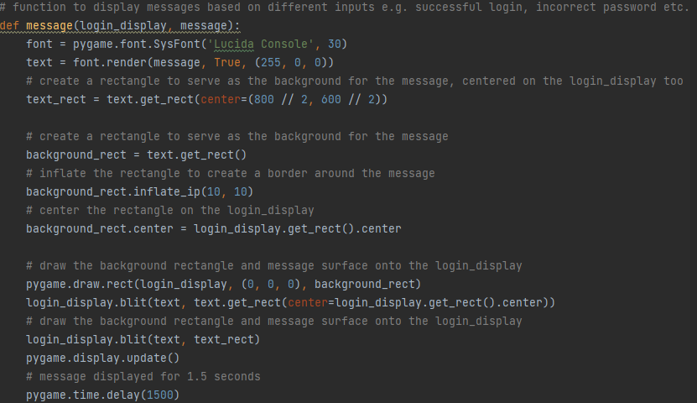

### Validating inputs

I then created the validation function, it checks and ensures that the username and password are not blank or over 14 characters and every character must be alphanumeric. If any of these statements are false the validation is failed and an appropriate error message is displayed  
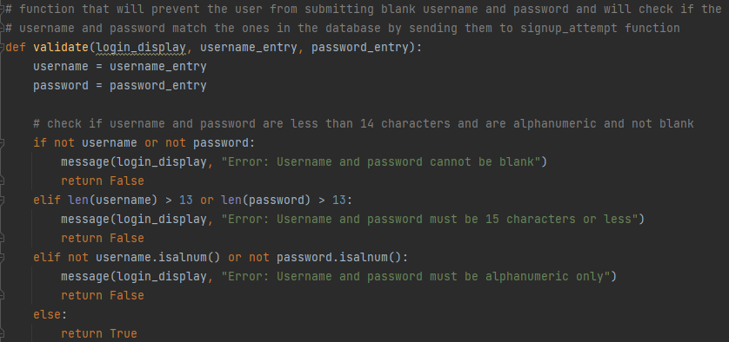

### Login button pressed

To prevent brute force attacks, I connected the login button to a “on button press” function that counts the number of incorrect login attempts for attempts WITH valid details, if the number of attempts exceeds 5 the system will close with an error message. If the attempts maximum has not been reached, then the login_attempt function will be called.

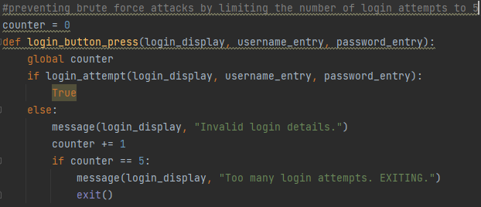

Below I have created the login_attempt function it starts by checking if the user data file is present and if it is it makes sure it is of the dictionary data type, once that is verified the system searches through the loaded data base comparing the entered username to the username field in the data base, and if a match is found then the password is hashed and compared to the hashed password in the record that was just found by the username search. If the encrypted passwords match then the maze_game is launched and the user_ID associated with the username and password entered are passed to the window for use in the maze_game file.

If any errors in the username, password or file are found then an appropriate error message is outputted and the login is a failure. Triggering a counter += 1 in the login_button_press function.

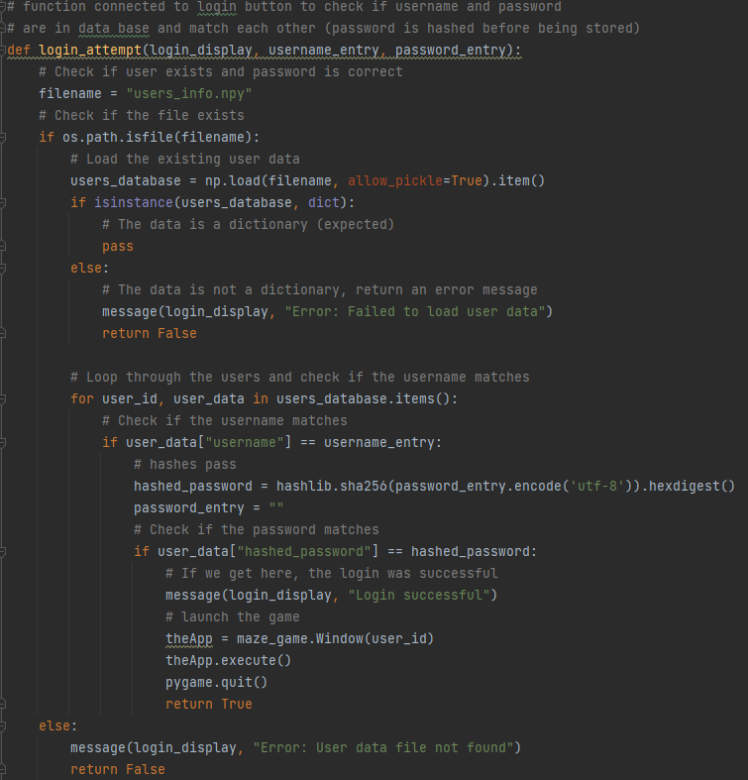

Note I found hashing the password quite complex as ive never done anything like it before however I found a useful article[12]telling how to do it and how it works.

### Sign up

Below is the function for a signup attempt, this is only triggered after the signup button is pressed and both the inputted values have been verified, once they have been the information is passed to the signup_attmept function, it starts by checking if the username is already taken by loading all of the existing records and cycling through the username column.

If any duplicates are found an appropriate error message is outputted and signup is a failure. If no duplicates are found a Universally Unique Identifier (uuid) is generated using the uuid python module this almost guarantees unique identifiers as it works on a combination of random numbers, time and, hardware codes like MAC address. This ensures there are no collisions. Once a user_ID is established then the values passed from input box can be saved into the dictionary corresponding to the user ID just generated, a default high score of 1 day is used for new users. Note that the password is hashed before being stored in the data base for security purposes it is then encoded with the utf-8 standard turning each character into 8 binary digits and then converted to hexadecimal for more efficient storage. On a successful signup a messages is displayed and the data is all saved.

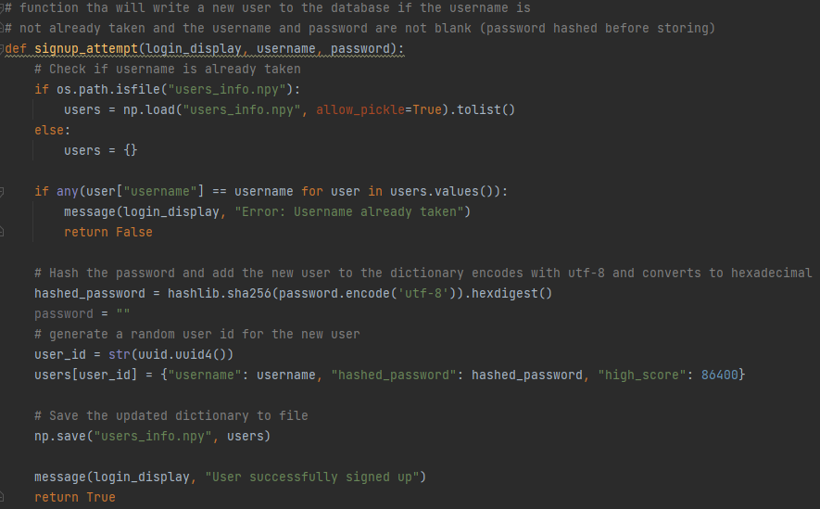

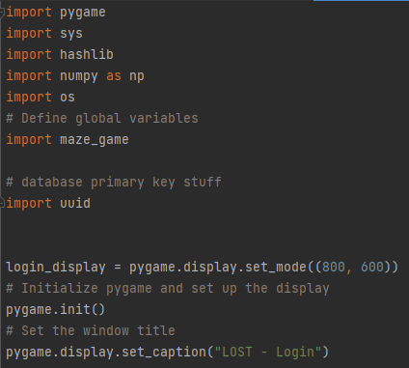 On the left is a all the modules I needed to import for this to work. The display resolution is also set along with the windows caption

### Maze_game changes

as I have completely changed the structure of how high scores are stored using this login system many aspects of the main game need to be adjusted to use this new format.

I started by changing the load score function to access the correct item of data from the record. This function is nice because no data needs to be passed for it to work, it simply accesses the user_ID itself as the user_ID is already passed as the game is logged in. a check is done to ensure the database is present and the data requests datatype is checked too to ensure no errors occur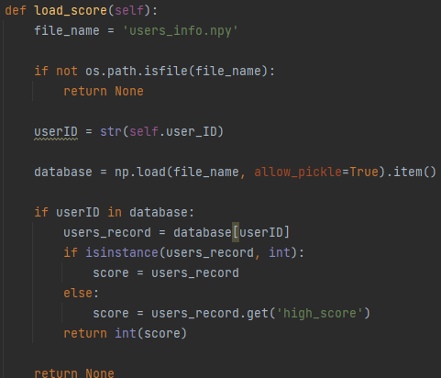

I also created a very similar function to get the username from the user_ID this is because I wanted to display the username next to the high score in the menu.

This function’s structure is the exact same as load_score and does a very similar job.

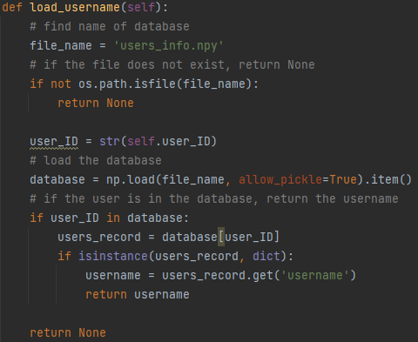

Below is the modified welcome screen code that uses the new username and score fetching system. All the data is accessed directly from the database ensuring it is always the most up to date info.

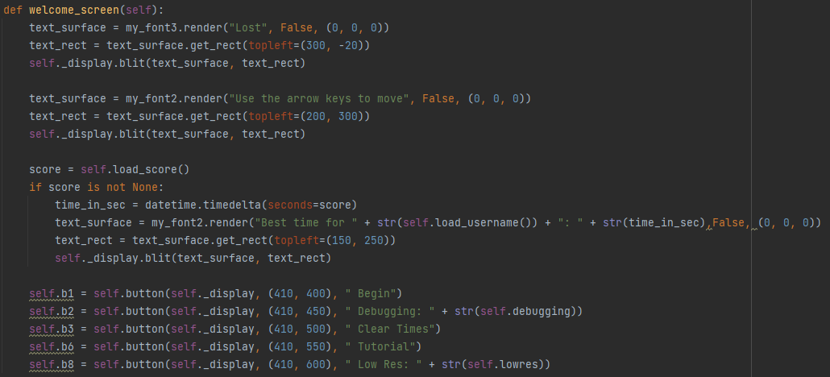

Below is screen shot of what the menu looks like for a new user with username “user”.  
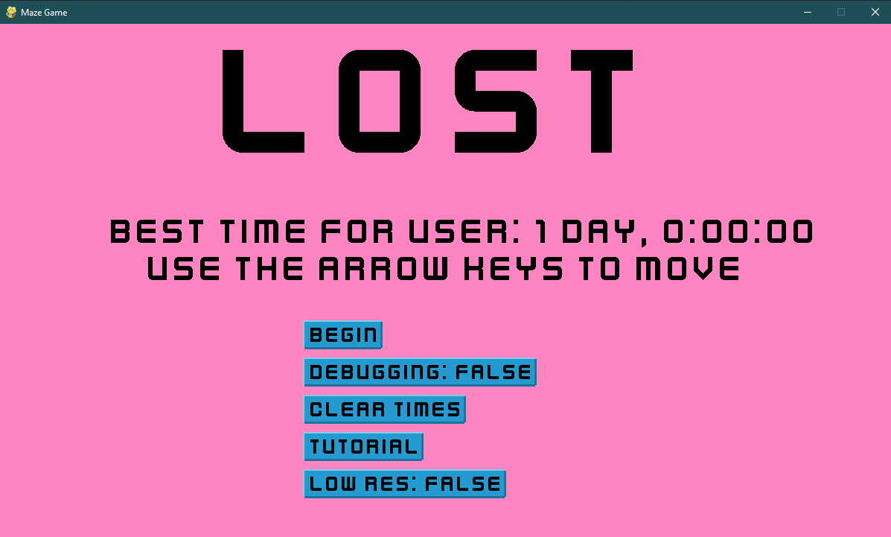

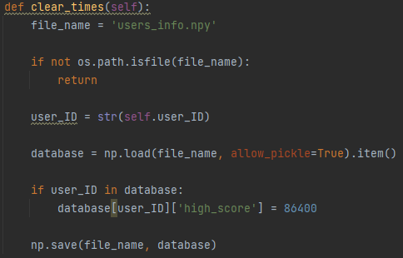The “clear times” button was also broken so I made some changes to fix that, I started by checking the database exists then I simply access the record connected to the User_ID and then save a default high score of 1 day to the correct field.



Above is the line used in maze_game.window that calls maze_game.user, I had to pass the highscore,filename and userID to the user class to allow myself to create functions that work using the new database. That meant that I had to define the variables in window too like this:

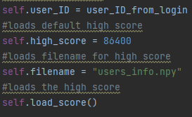

Below is the updated user class __init__ function with the added data necessary for the updated database system.

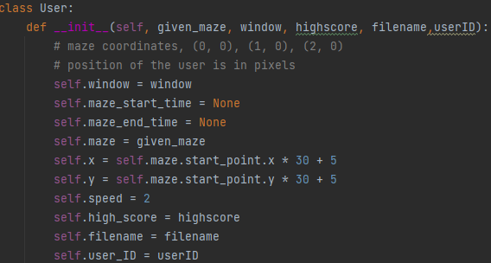

Log time was the only function that needed modification, I started by leaving the existing total_time variable as I would need it later, I then created the UserID by getting it from the user class, then I accessed the database and searched it until I found the record that matched the userID, once I had the record I compared the high score field to the total time I made earlier and if total time was lower I replaced the high score with the faster time and saved it to the database.

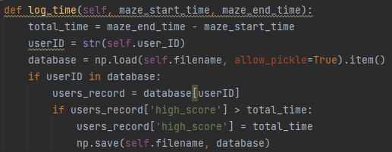

At this stage the login screen has been completely implemented and is integrated into all aspects of the program it had effected when first developed. Below is a screenshot of the login screen with a username = user, and password = password.

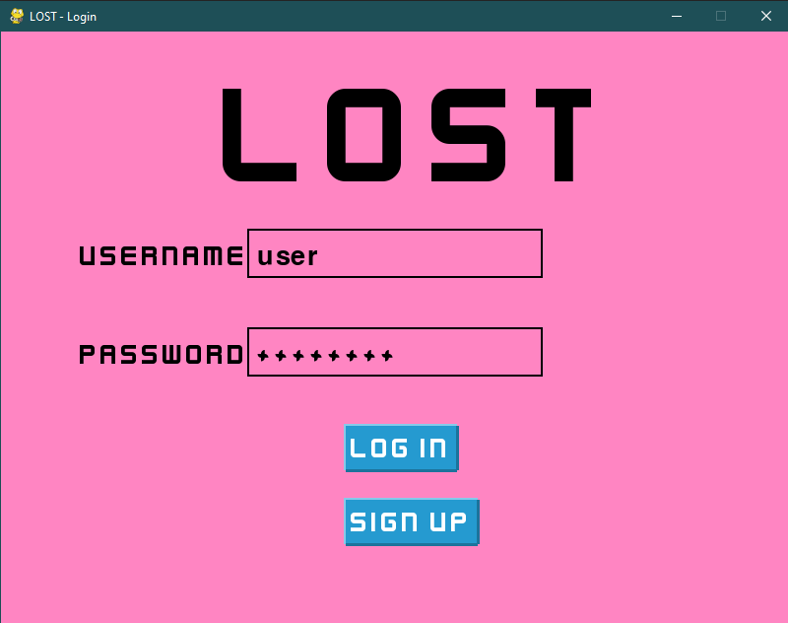

Overall, I am very happy with the final version of the program produced shown here. Below I am going to carry out the testing section of my project.

# Testing

Below I have colour coded a table with analysis of the post development testing I planned to do at this stage.

The colour of each box shows its level of importance in the final version

Needed, optional, unnecessary

|  |  |  |  |  |  |
| --- | --- | --- | --- | --- | --- |
| Feature to be tested | | How it will be tested | | Measure of success | |
| 1) Does program start/run without error | | Click run and go through all input options | | No syntax error when program is run  [SUCCESS] | |
| Evaluation: this feature of my program has been met entirely, after stress testing the program with rapid keyboard and mouse inputs and also after testing for glitches and bugs. the final version of the program has no errors to be corrected at all, after implementing the “low-res” mode for low end hardware it is safe to say crashes have been negated too.  [this is being tested to confirm success criteria 2] | | | | | |
| Evidence: | | | | | |
| 2) Do path finding algorithms complete mazes in a timely manor | | Using stopwatch to measure time between start and finish | | X < 45seconds  Ensures users will not think program is frozen or broken  [SUCCESS] | |
| Evaluation: this feature of my program has been met entirely; all algorithms implemented into my game complete their processing in the desired time frame I chose when creating their animation. For example, the Dijkstra and A* algorithms both move onto their next search at the same controlled speed. The maze generation algorithm also begins as soon as the game is opened making it appear instant as soon as the user presses the begin button.  [this is being tested to confirm success criteria 3] | | | | | |
| Evidence:    A screenshot of a computer  Description automatically generated with medium confidencehere you can see both Dijkstra’s and A* algorithm completing a randomly generated maze in a timely manner, the gifs have a low framerate causing stuttering not noticeable when playing the game. | | | | | |
| 3) Do path finding algorithms use reasonable processing power | | Using task manger whilst running the program to ensure CPU GPU and RAM usage is below X | | X < 80%  Ensures that hardware device will not crash whilst program is running  [SUCCESS] | |
| Evaluation: this feature of my program has been met entirely, all of the algorithms are efficient and do not cause lag or crashes when running. After monitoring my system hardware, when Dijkstra or A* is running on particularly long routes the CPU may increase usage around 10% and GPU 15% this is because of the animation.  [this is being tested to confirm success criteria 1] | | | | | |
| Evidence: in this GIF you can see the task manger performance bar to the left of the game, as the video is low resolution you cannot see the graphs properly. However, the usage results are in the evaluation above. | | | | | |
| 4) Exiting game | | Playing a level and ensuring that the game does not wipe progress saved in a basic .xml file | | Run through a level to get a high score then exit the game using “esc” key and re-open it, check high score tab and see if previous score remains  [SUCCESS] | |
| Evaluation: this feature of my program has been met entirely, the game closes as expected with both the “esc” key and “big red x” button and data is always saved. Even if the game where to close down unexpectedly (e.g., task manager end task) all data would still be saved because high score times are logged when a level is completed, and not when the game is closed. | | | | | |
| Evidence:  In this gif you can see the game storing the high scores correctly and accurately even if the game is shut down unexpectedly using task manger.  Please email my teacher [sjalal@ecgbert.sheffield.sch.uk](mailto:sjalal@ecgbert.sheffield.sch.uk) for witness statement | | | | | |
| 5) Accessibility options | | accessibility button opens the windows display calibration window | | The windows menu opens via the button and the filter overlays the game correctly  [FAIL] | |
| Evaluation: this feature of my program has not been met. I decided that accessibility options were not required for the game as the game only features block colours which essentially make filters pointless for colour blind users. In the future I may add colour customizability which would have the same effect as colour blind filters except everyone not just the colour blind will use them. (Most colour-blind users also use Microsoft’s accessibility options built into their system by default and this program does not interfere with those settings)  To ensure the game is acceptable to a wide audience, the language used in instructions has been kept simple. This has been tested in Microsoft words accessibility option. | | | | | |
| 6) Latency | | Moving mouse and feeling if it responds as expected | | Mouse does not drift, swing, lag, jump or feel unresponsive  [SUCCESS] | |
| Evaluation: this feature of my program has been met entirely, there is no noticeable latency when using the mouse cursor in the menu and button response times are also unnoticeable, also worth mentioning no cursor drift or stuttering even when algorithms are running. | | | | | |
| Evidence:  in this gif I demonstrate that the movement of the mouse is accurate and precise, notice the mouse has no “drift” or “momentum” when being moved around the page.    this second gif also shows the low latency of my programs character movement. (it's more responsive than the arrow key visualiser) | | | | | |
| 7) Do path finding algorithms work correctly within the bounds of the maze | | Run an example path finding algorithm and see if it reacts to the walls of the maze | | Algorithm responds to walls as expected and turns round corners  [SUCCESS] | |
| Evaluation: this feature of my program has been met entirely, the path finding algorithms in my maze work as intended, when I created this test I thought the algorithms would be given control of a sprite similar to the users character, and that that sprite would then traverse the maze creating the possibility of the algorithm not working well with the format of the maze, however my implementation of the path finding algorithms ended up being very different and the algorithms are actually given access to the colour of the maze and to display their animation they simply fill one square of maze at a time.  [this is being tested to confirm success criteria 3] | | | | | |
| Evidence:  Here you can see the algorithm searching through the maze correctly, it is using Dijkstra’s algorithm to calculate the shortest path and does so correctly. | | | | | |
| 8) Does level completion create a measurement of time taken | | Play a level and see if the time taken to complete the level is accurate to that of a recording made on another device e.g., phone | | The clock counting the time at the top of the screen starts, counts, and stops correctly  [SUCCESS] | |
| Evaluation: this feature of my program has been met entirely, the time recording system is extremely accurate and is also saved in a secure fashion. Time recording is started as soon as the perimeter of the player breaches the perimeter of the start square as is indicated by the start square flashing, once the recording is started it cannot be stopped or reset. The time recording is stopped and stored as soon as the perimeter of the player reaches the perimeter of the end square. This system is working perfectly.  [this is being tested to confirm success criteria 2] | | | | | |
| Evidence:    Here I have used a stop clock alongside the game to ensure the accurate measurement of time, the score stored by the game is accurate as I scrubbed through the full quality MP4 file and calculated the amount of time the stop clock was out by. The stop clock was started 0.4 seconds early. | | | | | |
| 9) Is level completion time measurement stored in a file if new high score | | Play a level slowly, then play the same level to get a better high score and then exit the game and load back on and see if the leader board has the better time stored for that level | | The leader board contains the expected result and retains the value  [SUCCESS] | |
| Evaluation: this feature of my program has been met entirely; time is stored regardless of whether if the time is a new high score this allows for game history to be recovered if the user desires but that has not been implemented as a feature yet. It is the programs responsibility to choose the lowest time to produce a “high score” on the menu page. This method of storing time is working very well and creates a very accurate time.  [this is being tested to confirm success criteria 2] | | | | | |
| Evidence: | | | | | |
| 10) Does menu screen buttons work | | Click the buttons on the menu and see for example if the “start” button loads you into the maze selection window | | Buttons carry out the function they are expected too  [SUCCESS] | |
| Evaluation: this feature of my program has been met entirely, the buttons in my game work perfectly as intended, they have an unnoticeable latency and precise hit boxes, I have implemented a custom version of a button I found online[8] they also adjust their size to fit any text size and length. | | | | | |
| Evidence:  this gif is to prove the functionality of the buttons I have implemented, as you can see all buttons are responsive and serve their purpose | | | | | |
| 11) Does menu screen “tooltips/alt text” work | | Hover over the buttons in the menu screen and see if a small box containing additional information appears | | The tooltips appear when hovering over a button and disappear as soon as you are not  [FAIL] | |
| Evaluation: this feature of my program has not been met; I have decided against implementing this feature because I thought the explanation for the game would be better provided by an in-depth tutorial page with all the information in one place as opposed to small pop ups throughout the game. I could possibly release this feature in an update if a survey finds that users still struggle with understanding the features of the game. | | | | | |
| 12) Does menu screen audio “on off” work | | Click the volume button indicated by a “speaker” and see if the game music turns on or off | | Music turns on and off based on the state of the button  [FAIL] | |
| Evaluation: this feature of my program has not been met, I decided against implementing any volume control into my game as I decided not to implement game audio at all. Discussion with potential users suggested that SFX have the tendency to become annoying in repetitive games. I therefore decided that people interested in listening to music as they play the game would rather use a 3rd party app such as Spotify in the background. Sound could be implemented at a later stage if other feedback indicates this is required. | | | | | |
| 13) Do algorithms leave a “snail trail” in the path as they go through the maze | | Allow an example algorithm to run on the maze and see if the trail is left in the correct location and does not act as a wall | | Trail is left in the path of the algorithm and deletes after it finds a dead end until eventually there is a trail from the start to end node  [SUCCESS] | |
| Evaluation: this feature of my program has been met entirely, both algorithms show details of their maze traversal with full animation, the search algorithms successfully mark the areas of the maze which they have previously looked at and mark the currently selected node in a different colour, a “snail trail” is left behind the algorithm as it moves on and a line is animated connecting the start and end of the maze through the shortest route.  [this is being tested to confirm success criteria 4] | | | | | |
| Evidence:  in this gif it is demonstrated that the algorithms leave a trail of cyan where they have searched. | | | | | |
| 14) Do walls work as expected | | Move the character through the maze in an attempt to make the character clip through the walls or cause errors | | The character does not clip or jitter when interacting with the maze  [SUCCESS] | |
| Evaluation: this feature of my program has been met entirely, the walls and collisions in my game work as expected with no jittering, clipping, or bouncing when moving the character into walls. It is important to note that this system is customizable and will work for various player speeds and player sizes in case, I decide to add more customizability in an update. | | | | | |
| Evidence:    Here I attempt to move the character erratically to create clipping through the walls of the maze, the walls and character behave as expected. | | | | | |
| 15) Does maze generate correctly | | Watch the maze generate and watch to see if backtracking is done correctly | | Maze generates a in satisfying and fast manor whilst also backtracking effectively to create a perfect maze  [SUCCESS] | |
| Evaluation: this feature of my program has been met entirely, the maze generation I have implemented is completely random every time and uses backtracking effectively to fill every available square in the maze to create a perfect maze, it creates a maze very quickly as it is very efficient. It is important to note that the mazes dimensions can be adjusted to any integer value and the algorithm will still work as intended this enables for different size mazes to be introduced in an update later on if necessary. To test this, I deleted the GUI of the game and added some temporary animation to watch how the maze generated. | | | | | |
| Evidence:  A screenshot of a computer  Description automatically generated with medium confidence this shows how the maze is being generated graphically. | | | | | |
| 16) Does the spawn and end points within the maze generate apart | | Generate 5 mazes and check how far apart the start and end point are away from each other | | The spawn and end points marked on the maze in red are far apart consistently but still random  [SUCCESS] | |
| Evaluation: this feature of my program has been met entirely, I added function to ensure the maze always generates with the start and end points an acceptable minimum distance apart to ensure no “easy” generations are made. It works by calculating a heuristic vale between the start and end point and if its below 13 squares simply generates another maze, usually the requirement is met within 2-3 generations making this solution suitably efficient. | | | | | |
| Evidence: Below I have created multiple generated mazes and all of them successfully follow the rule of keeping the start and end point far apart. | | | | | |
| 17) Is program launchable from a .exe file | | Send the file to a computer that does not have python and see if it launches and runs | | The game launches without the need for the host computer to have python installed  [SUCCESS] | |
| Evaluation: this feature of my program has been met entirely, I have converted my python file into a self-contained executable file. This file requires no external dependencies including python itself, and will run as soon as the user double clicks the file, high scores are also saved within the .exe itself, I have also created a shortcut which can be pasted to the desktop for easy access to the game. | | | | | |
| Evidence:  below is a screen shot of the .exe file which runs the game with a double click without any setup or dependencies. | | | | | |
| 18) User controlled sprite movement | Test keyboard arrow key inputs  “up”, “down”, “left”, “right” | | | | If movement feels natural and is responsive  [SUCCESS] |
| Evaluation: this feature of my program has been met entirely, the player controlled sprite movement works as intended with complete functionality of the arrow keys as inputs, the keys can also be held down to allow the sprite to move at a constant velocity, it is important to note that keys can also be held down to create a new direction of movement, e.g. combing “up + right” arrow will make the sprite move at a 45˚ angle from the vertical plane. Note the below footage appears to be slowed down due to the gif’s fps formatting. | | | | | |
| Evidence: | | | | | |
| 19) crash testing + robustness testing REMIDIAL TESTING | create inputs in unexpected scenarios, use beta tester to help create said scenarios | | Program does not crash via any known methods  [SUCCESS] | | |
| Evaluation: for this test I had the beta tester play the game multiple times and told them to try and break the program, they found one bug which is if the arrow keys for character movement were pressed in the menu the program would crash. I was able to fix this quickly with an if statement checking if the maze had been started.  This error was similar to a bug I found earlier in development where if the mouse is clicked anywhere BUT a button the game would crash as it did not know what to do with the input. The fix is shown here: | | | | | |
| Evidence:  Game has not crashed after clicking background and moving arrow keys. | | | | | |
| 20) login screen only accepts alphanumeric characters to resist injection attack | I will my knowledge of the internal structure of the program to enter various inputs trying to get past my text validation checks | | the system will prevent any none alphanumeric characters from being entered [SUCCESS] | | |
| Evaluation:  for this test I launched my program and tried to enter a range of none alphanumeric characters such as symbols, I then tried to enter other keys I do have functions for such as “enter” however my system was able to avoid this being taken as a character input too. I then decided to copy and paste symbols into the text box however my system doesn’t support copy and paste so it did not work also | | | | | |
| Evidence:  this is the result of attempting to enter  123!”qweQWE into the username and password box | | | | | |
| 21) login screen only allows for 5 incorrect entries of user info | I will enter various incorrect passwords for an account I create for testing | | The system will exit after 5 incorrect inputs, preventing brute force attacks [SUCCESS] | | |
| Evaluation:  I created a new account username: test, password: 1234  I then entered various valid but incorrect inputs into the password field and on the 5th input the system closed with the message “too many login attempts. EXITING” after 1.5 seconds the program closed itself. | | | | | |
| Evidence:  result of entering 5 incorrect passwords | | | | | |
| 22) login screen encrypts password before storage | I will print the database that stores user data including the password and see if the value is encrypted in SHA-256 then encoded in utf-8 and converted to hexadecimal as expected | | The data base contains a record for user: test  With a unique userID, username, hashed password and a highscore [SUCCESS] | | |
| Evaluation:  I opened the python terminal and ran a command to print the database, after removing all text except that regarding passwords you the output below, ive colour coded the name and data of hashed password to make it easier to read, as you can see the hashed_password field is filled with the correct information I was talking about in the successful outcome box. | | | | | |
| Evidence:  PyDev console: starting.  import NumPy as np  >>>database = np.load("users_info.npy", allow_pickle=True)  >>>print(database)  #i then removed everything not regarding passwords  >>> 'hashed_password': '5994471abb01112afcc18159f6cc74b4f511b99806da59b3caf5a9c173cacfc5' | | | | | |
| 23) login screen stores all of user data in a single record | I will print the entire database and remove all but one record from the output, hopefully leaving me with all the information for one user | | The output will store all the data on one user in one record. [SUCCESS] | | |
| Evaluation:  I wrote a command into the python terminal to print the database then removed the other records not connected the username: test. I also completed two mazes with a score of 11 seconds and 15 seconds respectively, as you can see from the output only one record was made for the user and it contained the best highscore. | | | | | |
| Evidence:  PyDev console: starting.  import NumPy as np  >>>database = np.load("users_info.npy", allow_pickle=True)  >>>print(database)  >>>, 'e2fe2adb-96f0-4067-8b3f-5889b9f99e3b':  {'username': 'test', 'hashed_password': '5994471abb01112afcc18159f6cc74b4f511b99806da59b3caf5a9c173cacfc5', 'high_score': 11}  Blue = user_ID | | | | | |

Criteria analysis

|  |  |
| --- | --- |
| Completed? | **Success Criteria:** |
| **YES** | 1. A successful program should allow the user to play the game on low end hardware without noticeable performance issues |
| **YES** | 1. the user should be able to complete randomly generated levels and set high scores to an online leader board |
| **YES** | 1. the game should feature multiple advanced and simple path finding algorithms |
| **YES** | 1. the user should be able to watch the algorithms calculate their route in real time e.g., see the trail on the maze as it moves rapidly. |
| **NO** | Levels progress as mazes are completed, maze will increase in difficulty, with either size or complexity |
| **NO** | Software can access the internet to provide automatic updates |
| **2/3** | Successfully implemented A*, Dijkstra’s, Depth first algorithms |
| **YES** | Game should be able to be played by one player |
| **YES** | Levels should change after every completion |
| **YES** | Game should have a high contrast allowing for visually impaired users to access |
| **YES** | Login system hashes passwords before storing |
| **YES** | Login system will relate a username to a high score |
| **YES** | Login system should prevent massive data types |
| **YES** | Login system should prevent SQL injections |
| **YES** | login system will prevent brute force attacks |

Above is the success criteria I created for my program during my analysis stage. I have managed to meet all of the above primary objectives. I now consider my project fully complete.

After analysing this testing, I would say the program is a great success, achieving 13/16 features, including 100% of the “Needed” features. To deliver this project in the specified time scale I made the decision to not complete 3/16 features at this time. These features were optional and made no difference to the functionality of the algorithms implemented. These features could also be implemented at a later date if required.

Here I have attached an executable version of the python game to run it you must un-compress the file and double click the “MAZE GAME – click to run” file the file is self-contained so should not require any extra dependencies other than those which are already in the file directory.

|  |
| --- |
| Confirmation from Beta tester:  Magnus - “The menu was intuitive to use, and the features were interesting and useful. I generated a number of mazes, and they were all different, the algorithms performed as expected. In low resolution mode, the movement is responsive and natural, but on the school hardware, on the default settings, the game was much slower. The tutorial is descriptive and concise, while the high scores create replay ability.”  Overall, I think this feedback is fair and helps to prove the testing I have already carried out in the above sections, I also found that the “unseen” tester. |

## Usability testing + evaluation

Here I am going to beta test my program with the stakeholders I interviewed earlier in my project regarding the design of the program.

**Dan (M56)** – “Game was hard to play but after reading tutorial I at least understand the premise, I quite enjoy the game once I’ve played a few warmups, I just find the player too fast I would say the game meets most of my requirements as the tutorial does a great job of making the game easy to understand, oh and the buttons are nice and big so I can read them”

**Debbie** **(F52)** – “I’m a busy person and like a quick game. This great, easy to use and challenging! Overall, I would say the game meets my requirements as the menu is easy to work and controls are simple to use”

**John** **(M17)** – “I really enjoy this style of game, with so many shooter games flooding the market it was time for something different, could certainly use a good soundtrack though. This game definitely meets my requirements as the player movement allows for really fast game play if I focus properly. I like the algorithms too; I find them super interesting”

### Interface and Controls:

The Graphical user interface was considered easy to use and child friendly by all participants involved in testing. It was noted that there are no settings hidden within menus and all buttons are legible and that this helps make understanding the program easy. The controls for the game have also been kept as simple as possible, using only basic arrow keys. However, there is still room for significant skill progression as timing of the fast-moving character can always be improved.

### Analysis for different user types:

First time players:

The game has been designed with first time users as a primary concern. There is an intuitive yet detailed tutorial which allows the first-time user to quickly gain a basic understanding of how the game should be played. The game follows the same styling throughout creating less confusion when navigating to different pages of the software. Text within the program has been ensured to be clear and easy to read due to high contrast backgrounds. Controls have been beta tested to ensure easy usability for first time users, the controls are easy to understand and are explained well within the tutorial. The speed of movement is fast, however, every beta tester got used to the movement style within the first 3 games, this demonstrates a well-designed learning curve with enough difficulty to remain interesting but also easy enough to keep user attention initially.

Regular players:

The game has been designed with regular players in mind. The high score storage system is permanent and embedded in the games files making it difficult for the saved games to be accidentally corrupted. The times can also be cleared whenever the user decides necessary. The movement was designed to allow the user to progress their skill all the way from a beginner to an expert. A skilled player is able to hold multiple keys at the same time to create diagonal movements specifically for example:

Corners: beginners are able to approach a corner and stop above it before deciding which key will move them into the opening in the maze wall whereas an expert would be able to take the corner faster if the user brushes the character against the walls of the maze to instantly pass through the gap once the wall discontinues without stopping.

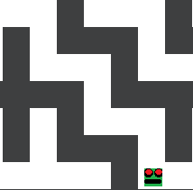

Diagonals: beginners are able to take each vertecise of the route step by step using one arrow key at a time using the wall perpendicular to movement to help stop and line up the next movement. An expert player would hold down both left and up arrow keys at the same time and the player will move rapidly in a diagonal direction thorugh the route.

Overall I feel like I have designed this game in a way which is able to meet the requirements of both a first time user and a regular player, with reasonable skill progression and easy to understand yet functional menus.

### Analysis of the GUI:



1. Text is in bold to increase readability
2. Buttons display settings within themselves to avoid cluttered menus
3. Highly contrasting colours make buttons unmistakeable for other text
4. “Use the arrow keys to move” gives a simple and short explanation of the game to those more familiar the mechanics of video games and do not require the full detail of the tutorial
5. Fixed resolution window makes games proportions identical across every machine the game is played on
6. As window in not Fullscreen allows for other applications such as Spotify to be easily usable in the background once playing the game
7. As all buttons have uniform spacing and thickness, they are easy to use

### Maintenance (1) / Limitations (2) / Improvements (3)

1. My program should require no maintenance updates in its current state as each copy of the game is isolated from the other installations as the program makes no use of the internet. I may release an updated version of the game on a forum such as GitHub if an update is required as that will allow me to bypass the lack of online connectivity in my game. I may also use a forum-based system to get user feedback, this will allow me to change which features I decide to implement first.
2. The security to the games high score storage could be improved as currently the file is accessible and modifiable (using the correct tools), this creates an issue for 3rd party online high score comparison websites such as speedrun.com as high scores maybe fraudulent with no way of knowing. Although in its current state modifying your own game files makes no changes to other user’s game play so it is not a serious issue. Note that the high scores file is not completely unprotected as it is enclosed within the .exe file so will be complex to access but still doable for an experienced user.

Another limitation of my program is that the window is a fixed resolution, this may cause issues with resolution scaling when the program is being ran on very high-resolution monitors (4k<) as the game window could appear smaller than intended. So far I have ran the game on a few different monitors with varying resolutions and have not encountered any issues but I do not have access to a 4k display so cannot be certain.

My game is also limited by the lack of a Fullscreen mode which I would like to implement later on if I had more time to do so, this feature is unnecessary, but I believe it is standard on most programs so would like to provide the user with the option.

1. Given more time I would like to encrypt this file to make it inaccessible to the user. This could be achieved by having the programs coder hold a key which is needed to write and modify the file. I would also like to create the option to lower the movement of the character if the user wants to have a slower paced game **to meet dans user requirement.**

I would like to implement the “tooltips” feature as it would provide a short description of every button in the program, I feel like this would make the software easier to understand and use for new users and make the game more accessible for users such as “DAN” who I interviewed previously.

I would like to implement the feature of game audio to make the game feel more fully featured. sound effects for button clicks, starting a new game and reaching the end point of a maze would make the game more engaging. I would also add the volume ON/OFF switch to give the user the option to turn off these sounds if they prefer.

## References:

1. <https://www.geeksforgeeks.org/a-search-algorithm/>
2. <https://stackoverflow.com/questions/61218945/best-algorithm-for-maze-solving>
3. <https://www.youtube.com/watch?v=GC-nBgi9r0U>
4. <https://github.com/jostbr/pymaze>
5. <https://www.youtube.com/watch?v=OZSZHmWSOeM>
6. <https://youtu.be/-L-WgKMFuhE>
7. <https://youtu.be/g024lzsknDo>
8. [How to make a nice button in Pygame | python programming](https://pythonprogramming.altervista.org/how-to-make-a-nice-button-in-pygame/?doing_wp_cron=1658318087.7818710803985595703125)
9. [Dijkstra's algorithm - Wikipedia](https://en.wikipedia.org/wiki/Dijkstra%27s_algorithm)
10. <https://en.wikipedia.org/wiki/Maze_generation_algorithm>
11. <https://en.wikipedia.org/wiki/Pathfinding>
12. [Python SHA256 Hashing Algorithm: Explained • datagy](https://datagy.io/python-sha256/)
13. <https://www.ncbi.nlm.nih.gov/pmc/articles/PMC4055506/#:~:text=The%20Advanced%20Cognitive%20Training%20for,function%20(4%2C%205)>.
14. <https://www.psychologytoday.com/gb/blog/ulterior-motives/201608/video-game-play-benefits-coordination>

### If you want to try the game:

If you would like a copy of the game, please email [goergeclark331@gmail.com](mailto:goergeclark331@gmail.com) and I will send you a .rar file that was too large to embed in this document.

Please remember the path finding algorithms are exclusively available in **debugging** mode, this is what you are looking for within the .rar file:



1. Once I completed all other sections of my program and had completely finished my documentation. I had some extra time to add a login system. All sections from here onwards containing information on a login system were added after ALL other features where complete which is why certain sections my not make chronological sense.